**IIS Hosting**

**Prerequisites**

Before you begin, ensure you have:

* **Windows Server** with IIS installed.
* **Administrator access** to the server.
* **Python 3.13** installed.
* A **Flask project** ready for deployment.

**Step 1:**

* Open Command prompt & Navigate to your project directory.

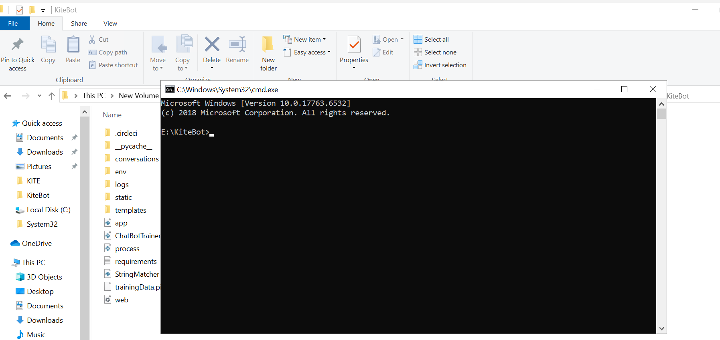

**Step 2:**

* Create a virtual environment using: python -m venv env

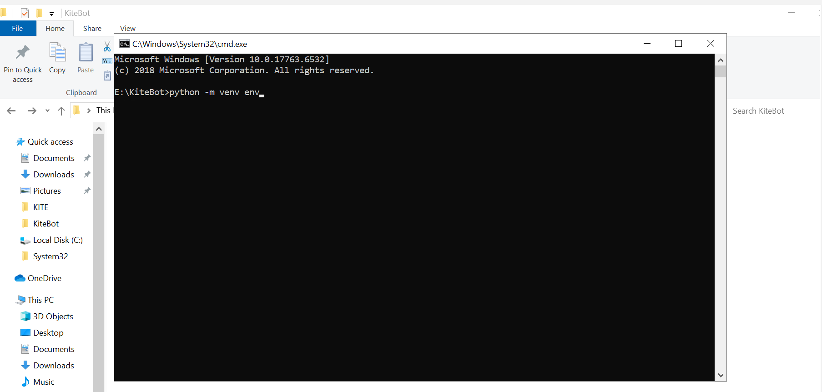

**Step 3:**

* Activate the virtual environment: env\Scripts\activate.bat

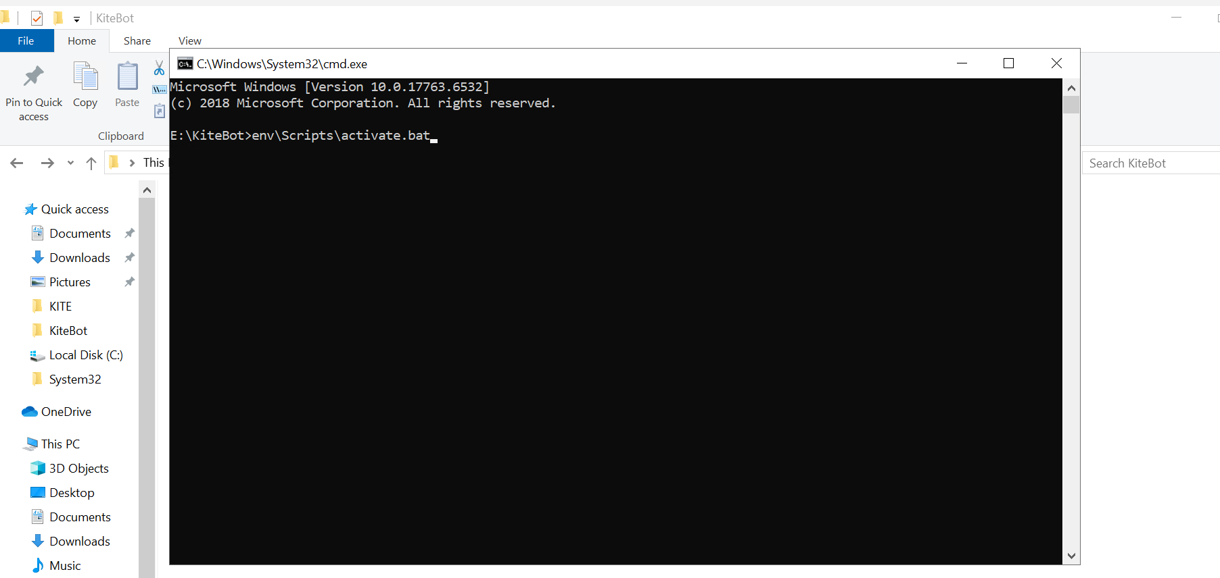

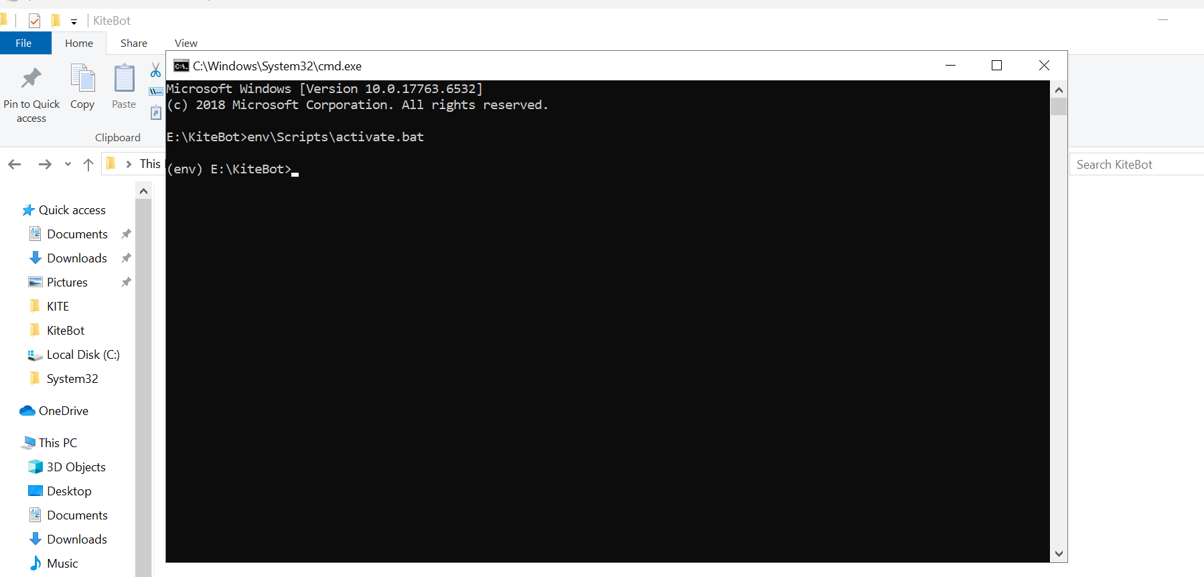

**Step 4:**

* Install Project Dependencies by using below commands one by one.

pip install flask

pip install pyyaml

pip install matplotlib

pip install talisman

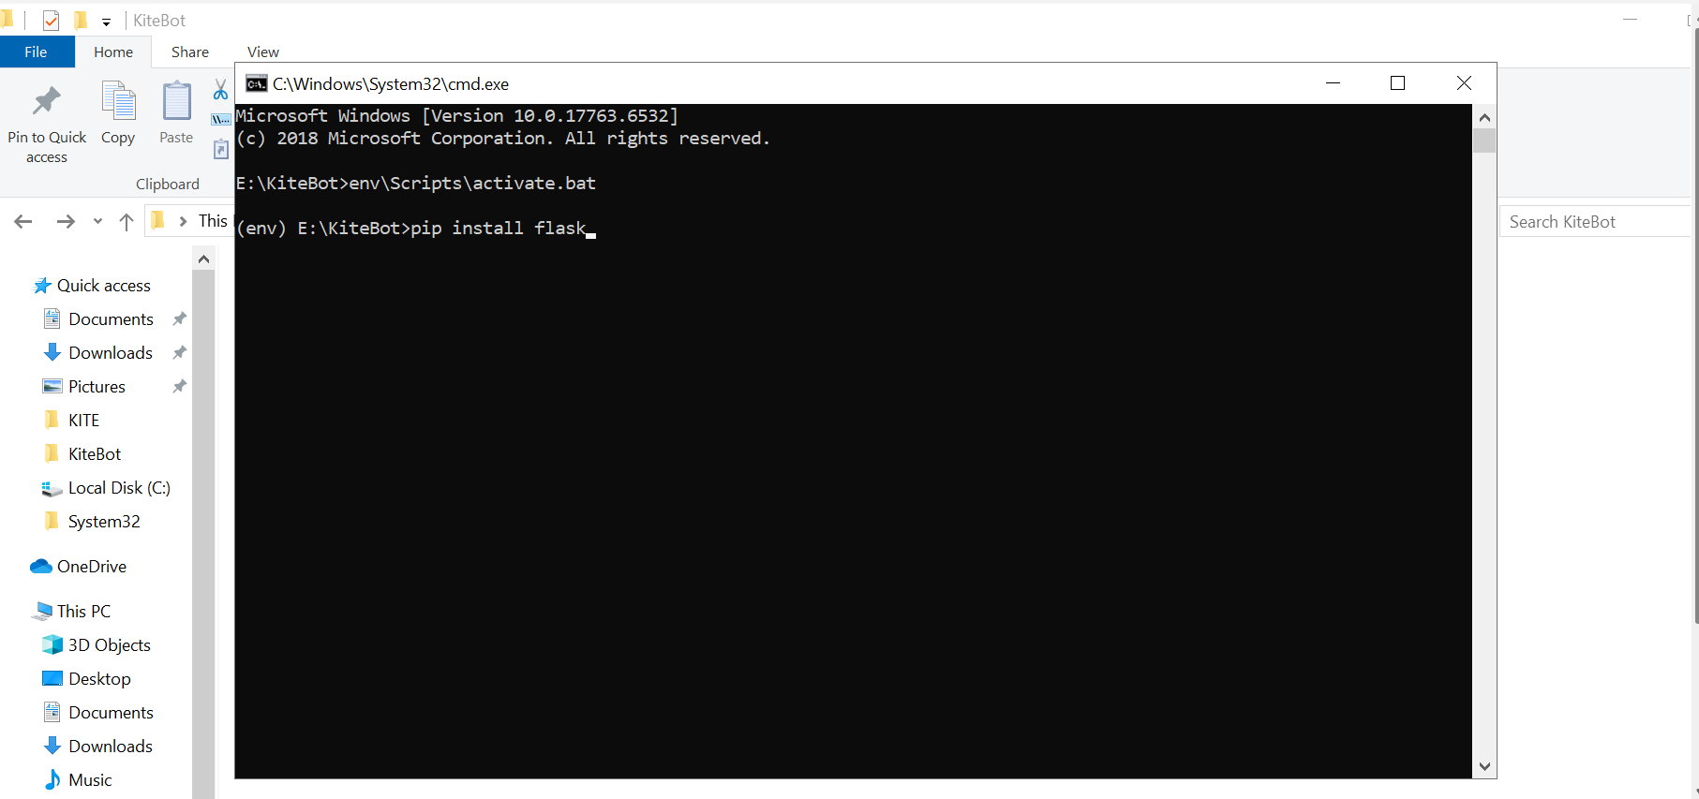

**Step 5: Create new site in iss need to be add steps add**

**Step 6:**

* Click on the site which you created, then click on **Handler Mappings.**

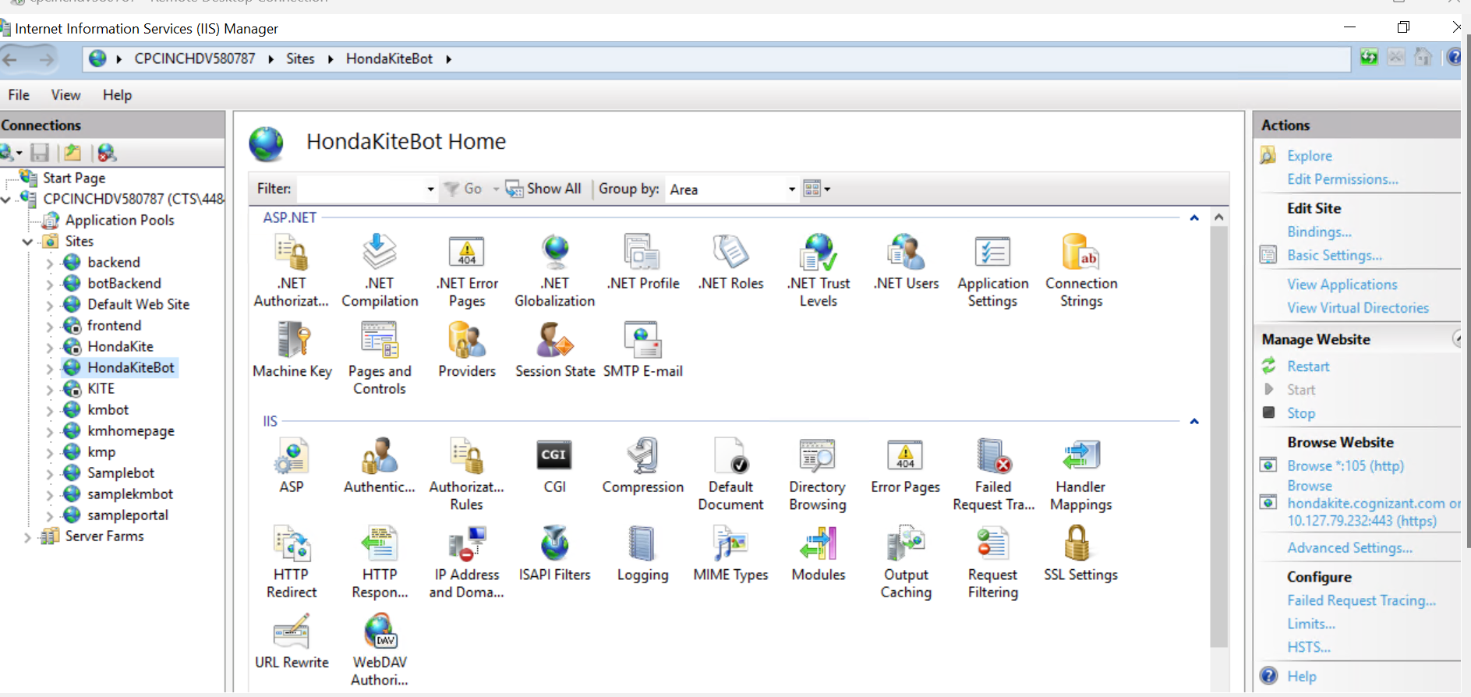

**Step 7:**

* Click on **Add Module Mapping.**

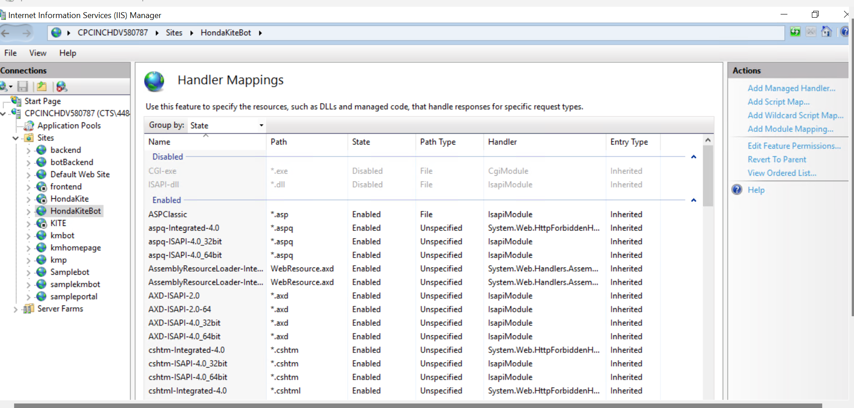

**Step 8:**

* Handler Mappings tab will be open**.** Need to enter the details.

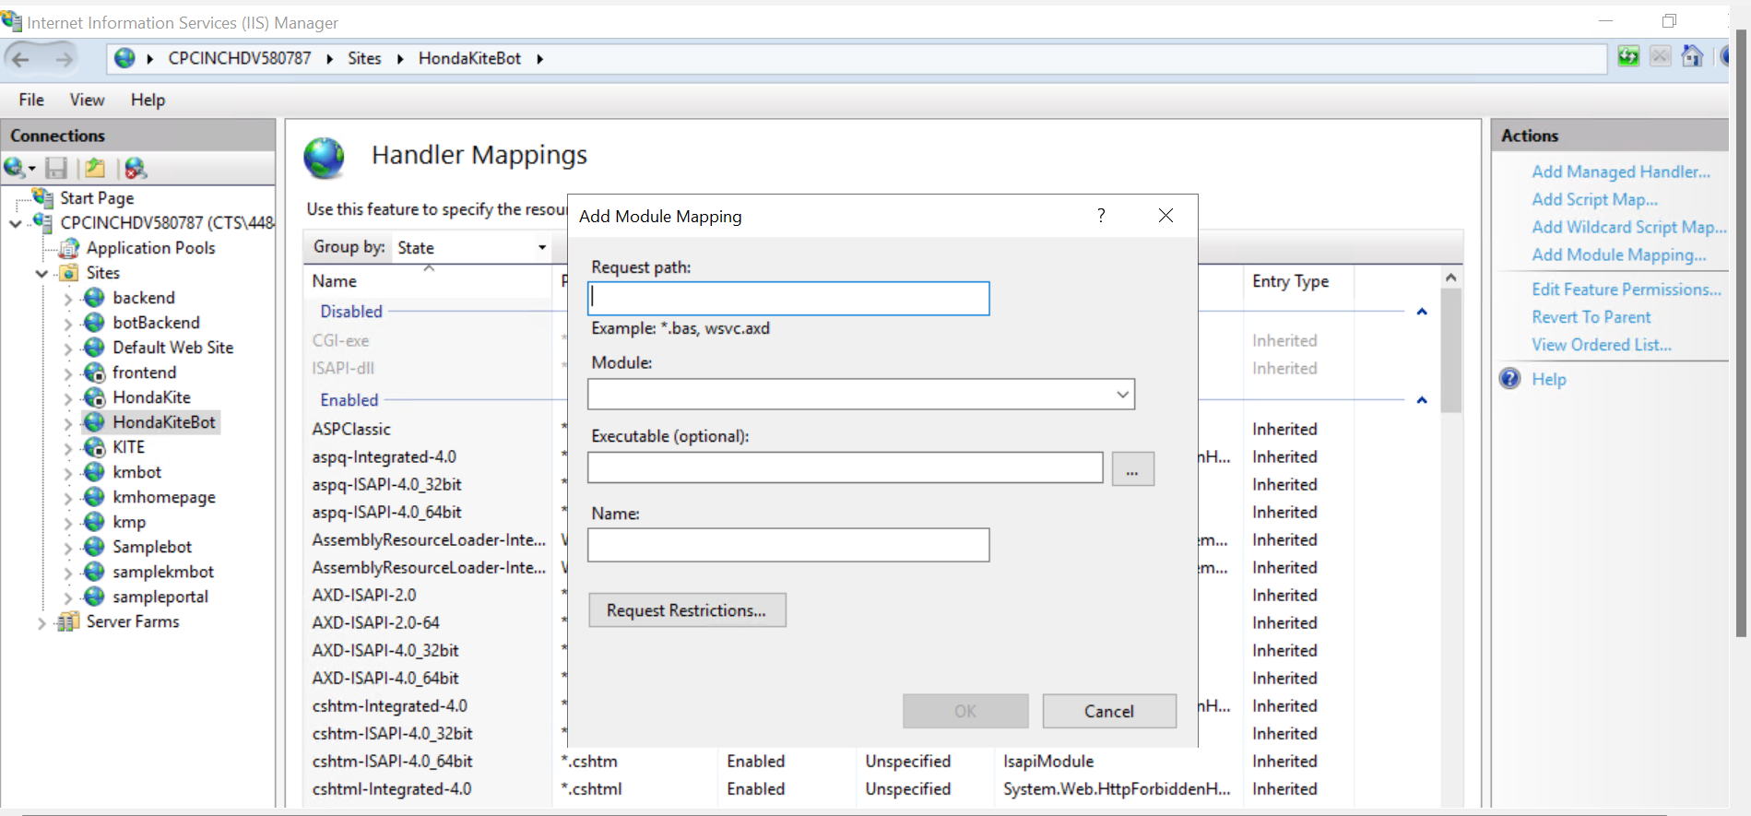

* 1. Request path - *
  2. Need to select “FastCgiModule” from Module dropdown. (Please follow step 9 if “FastCgiModule” is not available)
  3. Need to enter Executable path (please follow step 10 to get Executable path).
  4. Name – HondaKiteHandler.

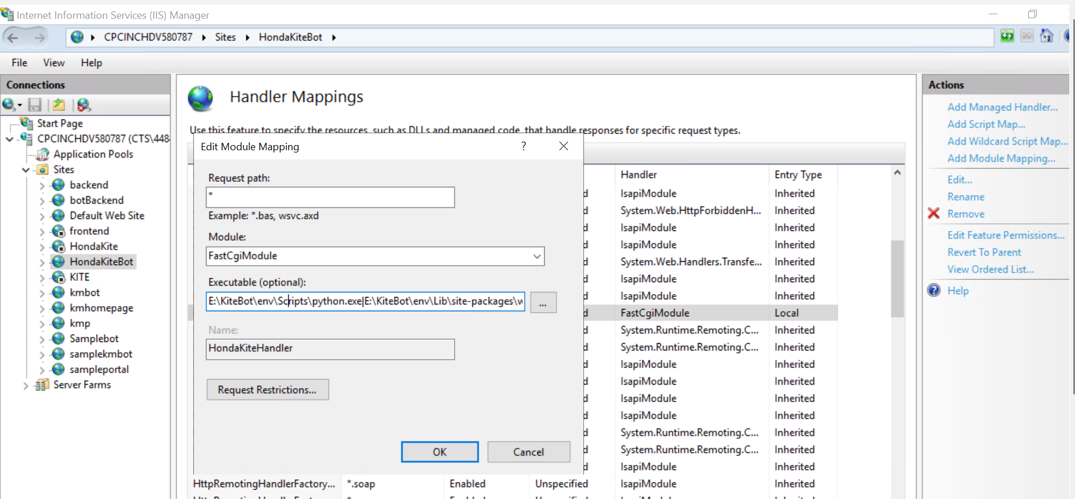

**Step 9: Install and configure wfastcgi.**

* Click on Search, type “**Turn Windows feature on or off**” and open it.

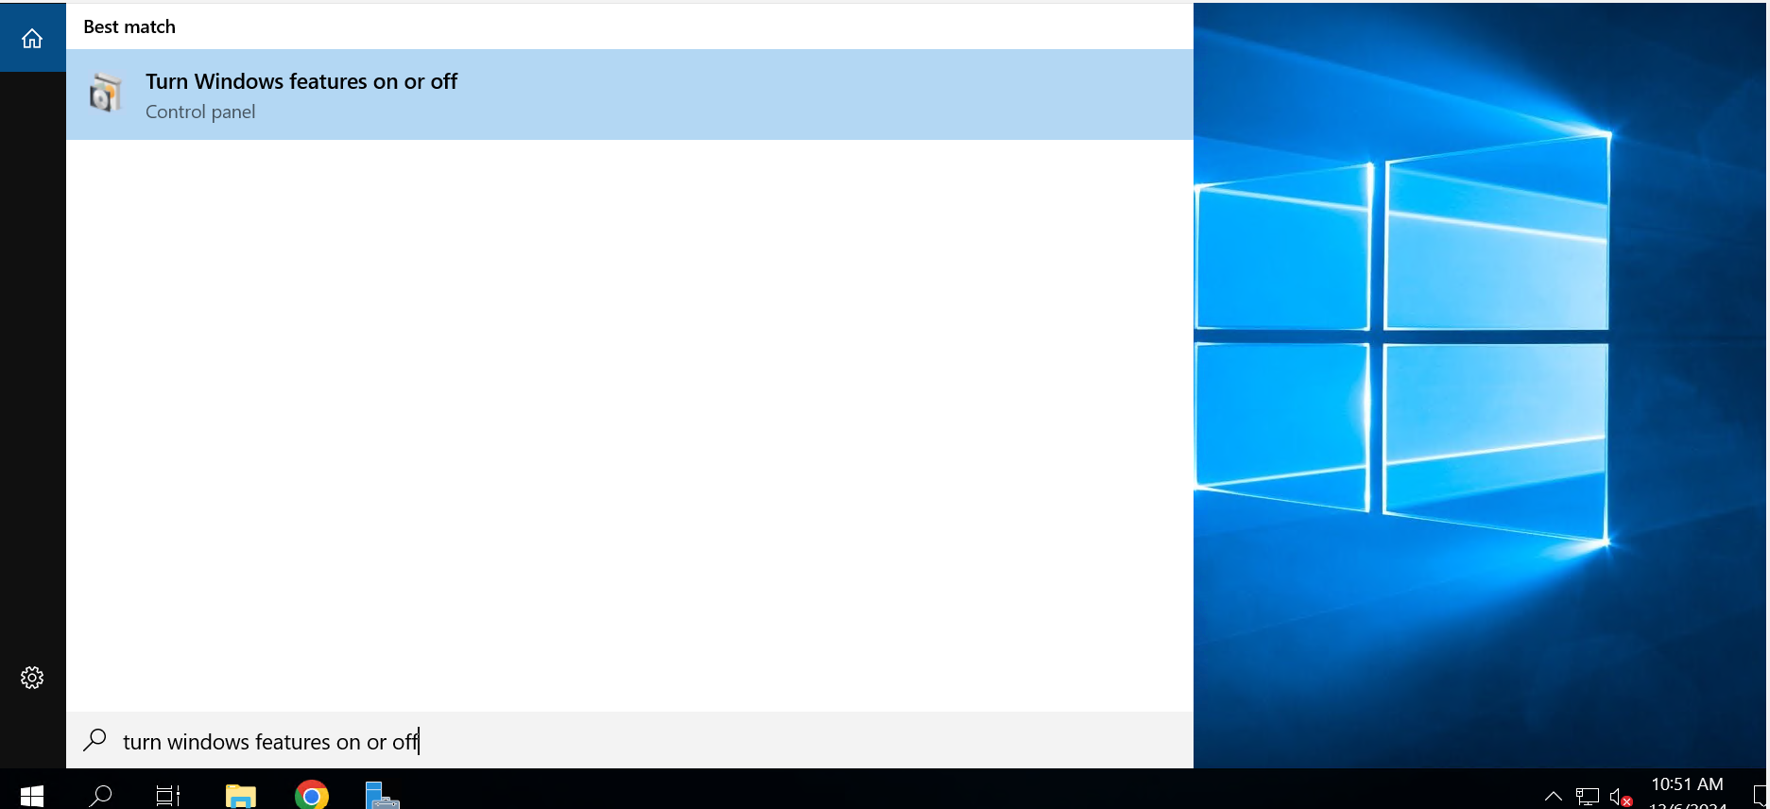

* Add Roles and Features tab will open. Click Next.

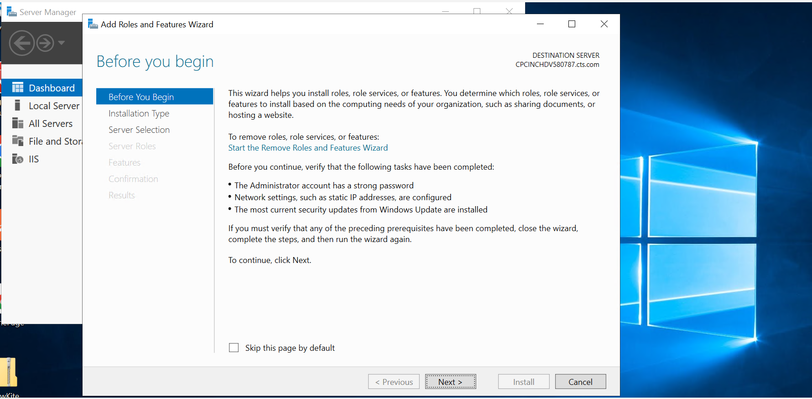

* Select Role-based and Click Next.

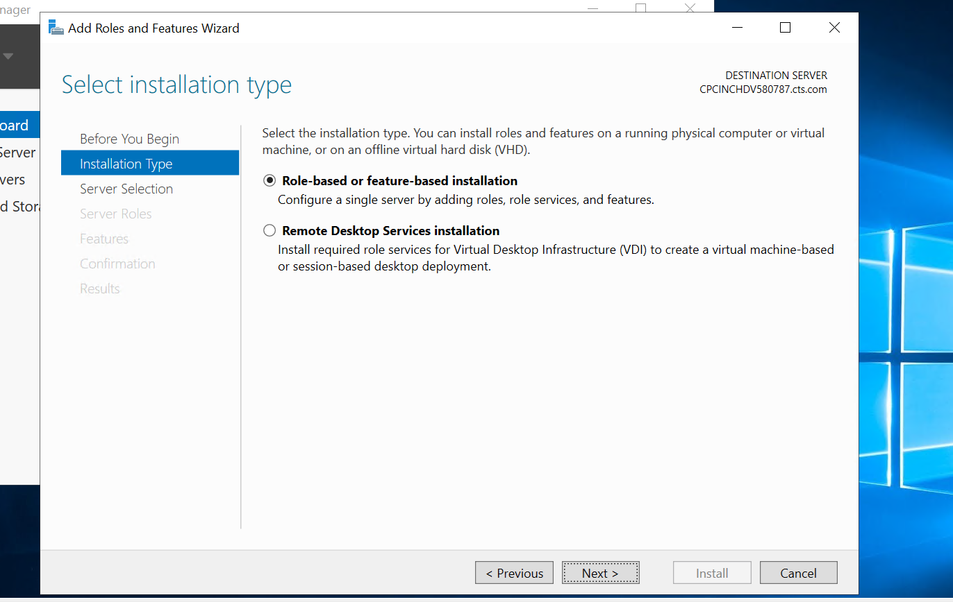

* Select your server and Click Next.

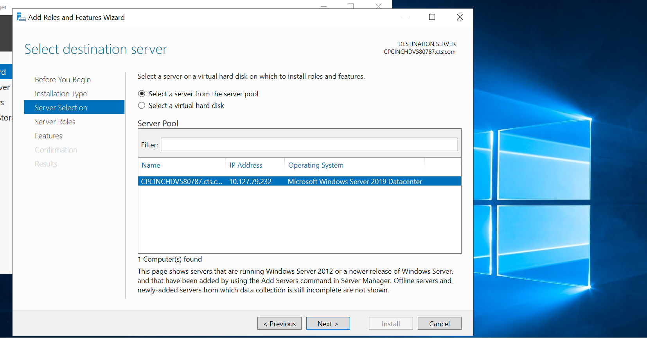

* In Server Roles section, Go to

Web Server (IIS) > Web Server > Application Development > Select CGI check box. Click on Next.

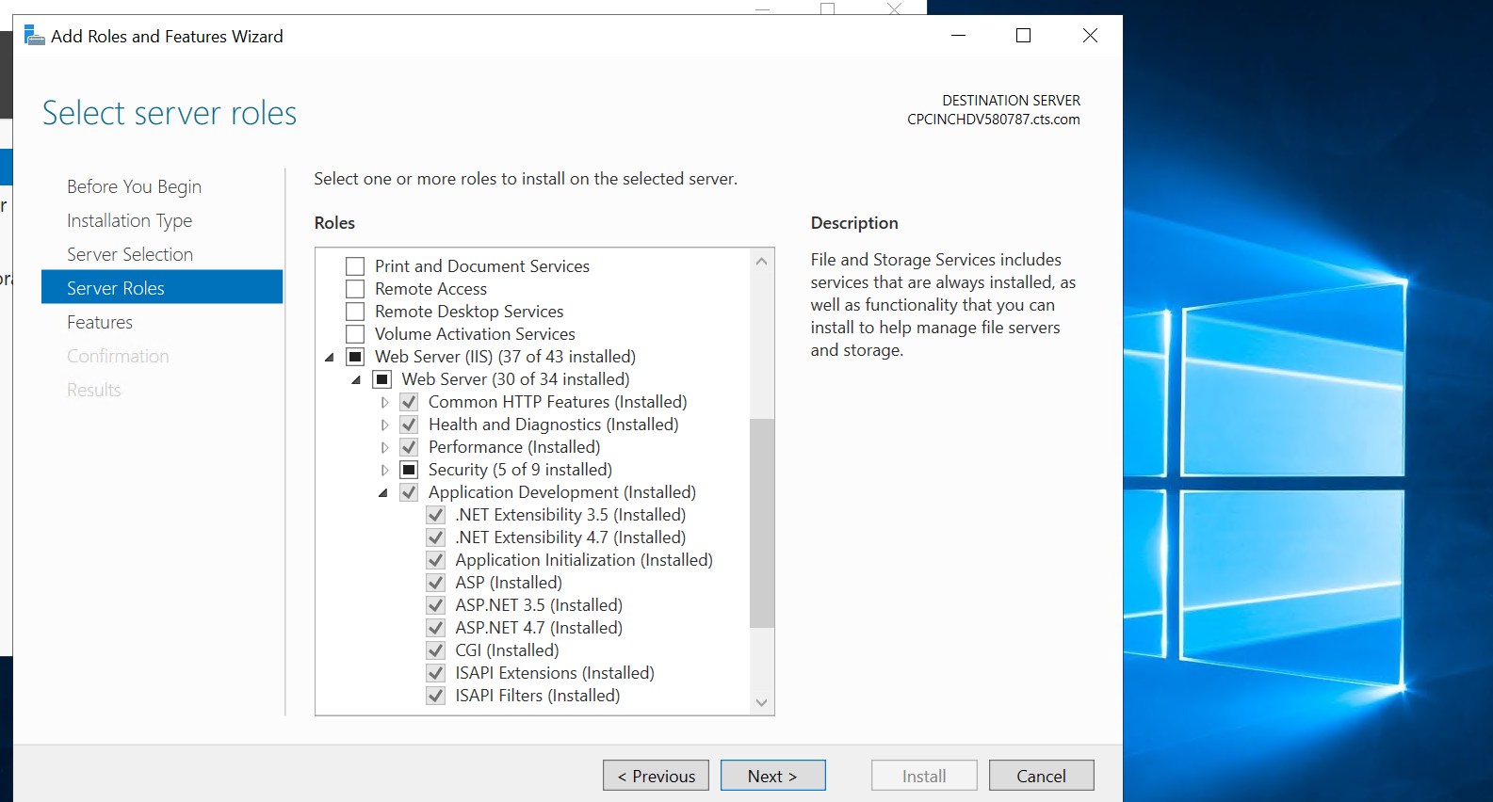

* Click Next.

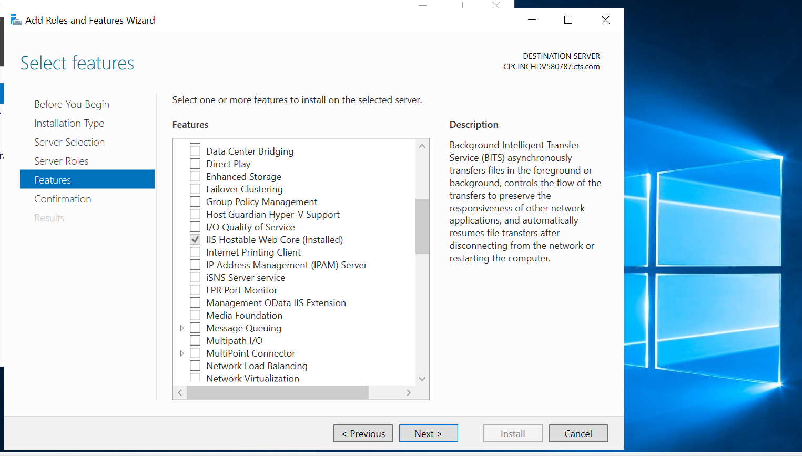

* Click on Install. After installing, you can able to select FastCgiModule in Step 8.

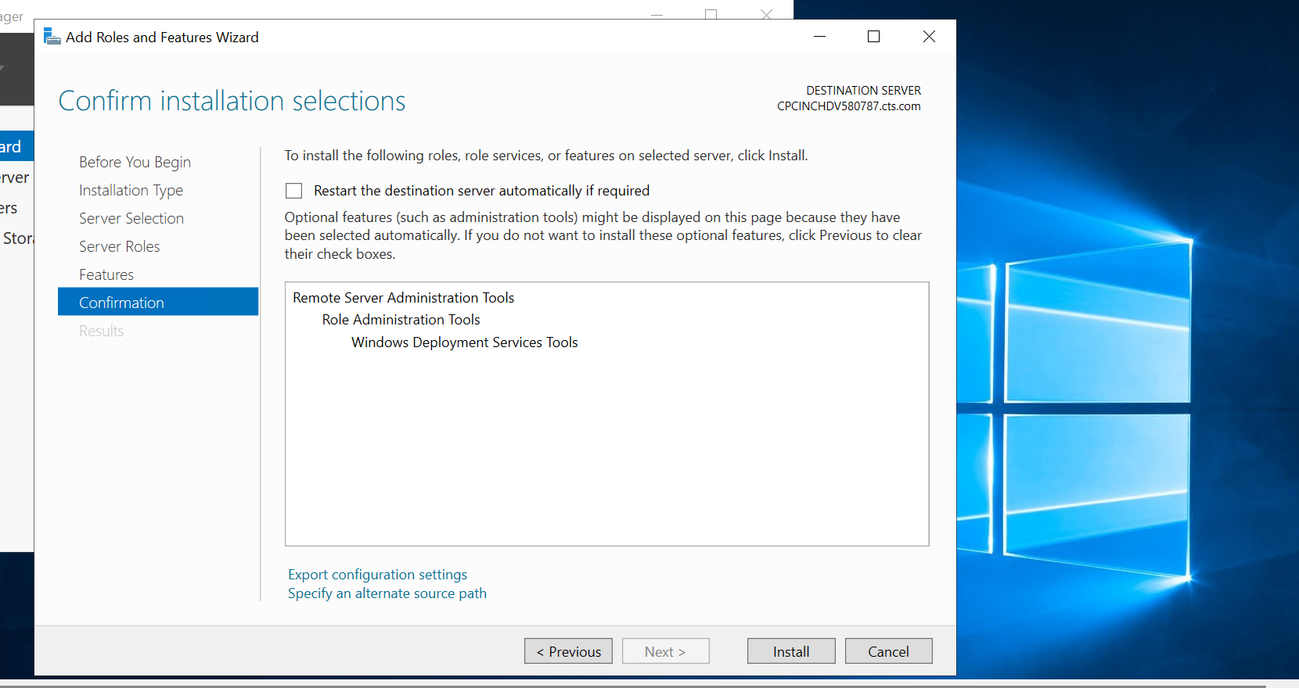

**Step 10: To get Executable path.**

* Open Command prompt as an Administrator

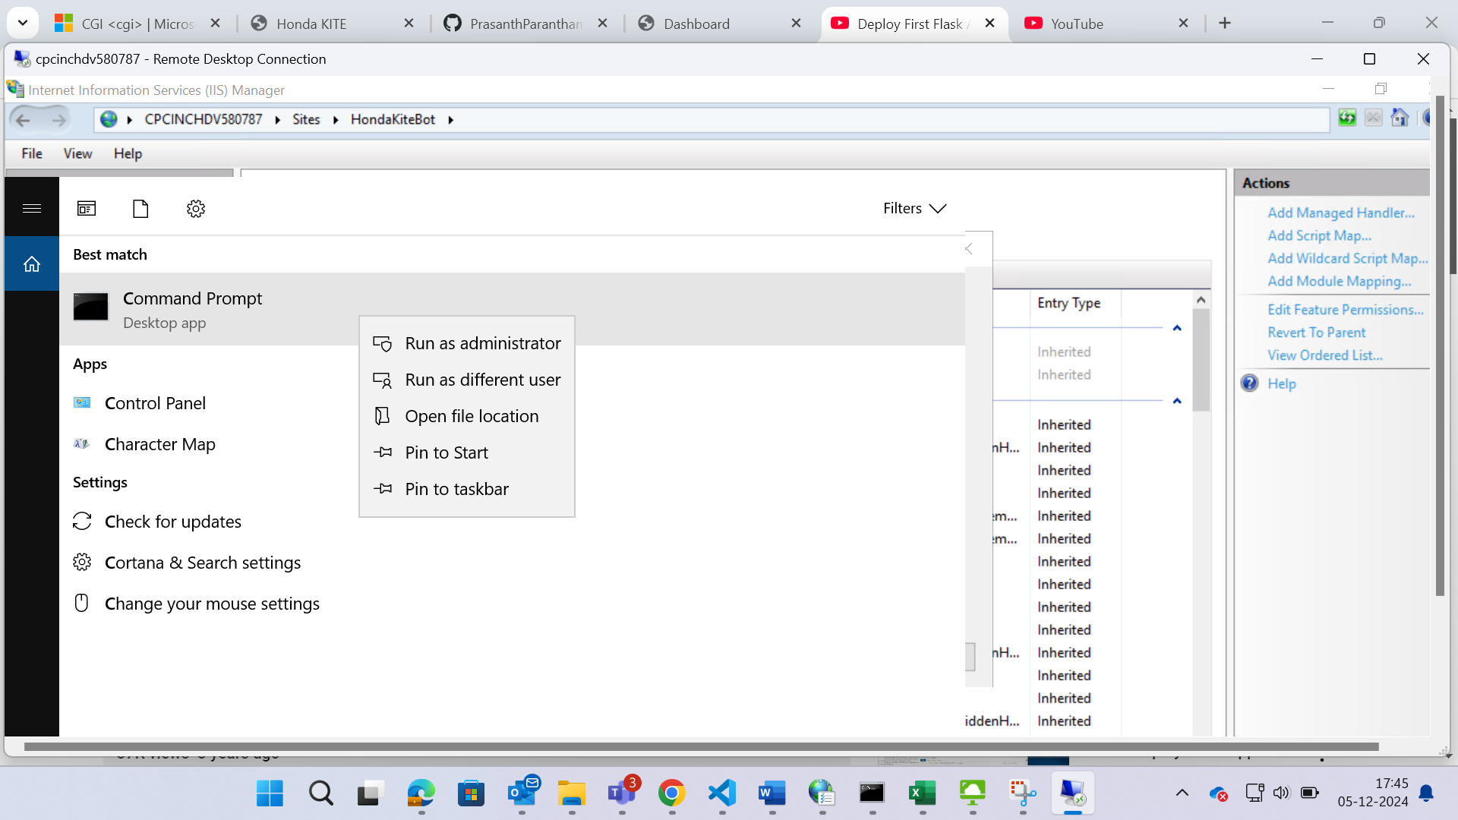

* Navigate to your project directory.

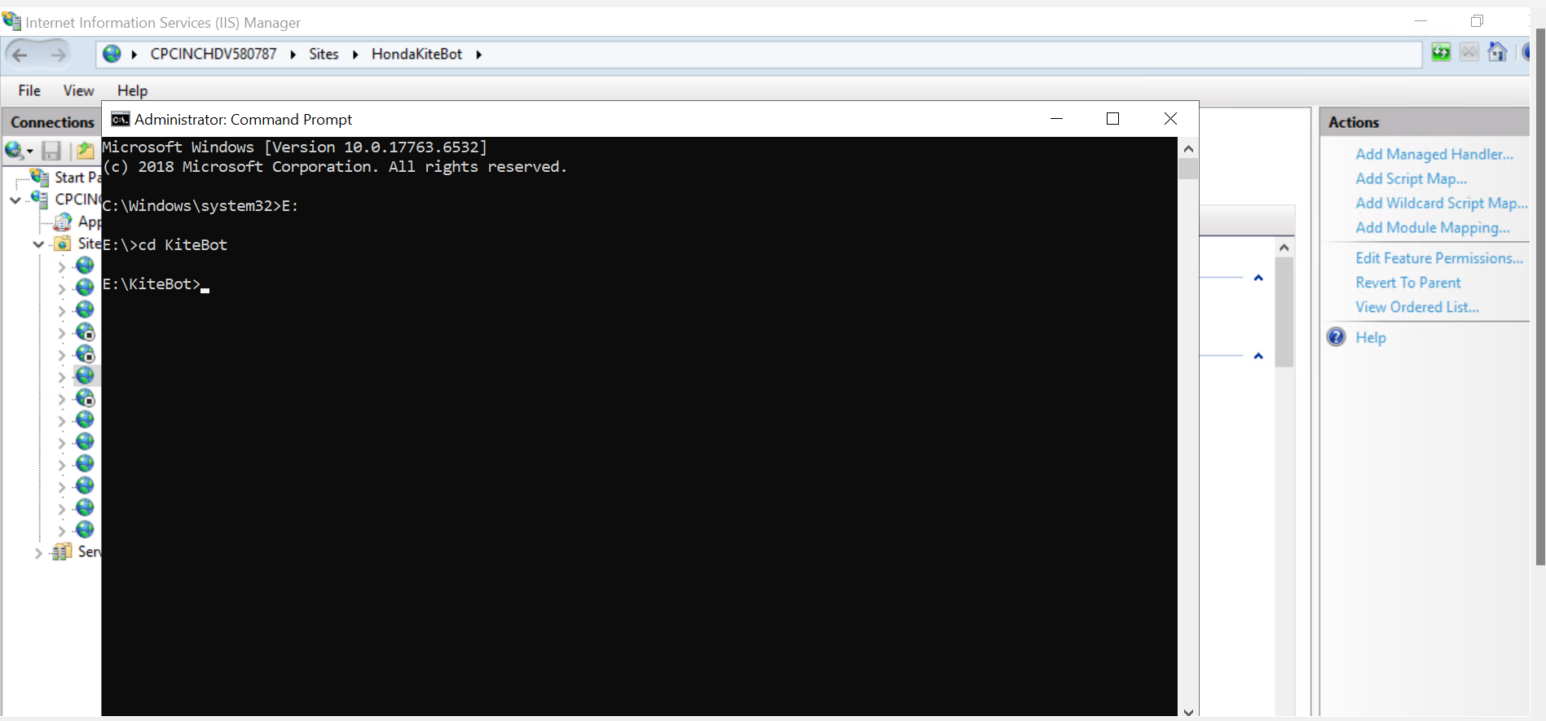

* Activate the virtual environment.

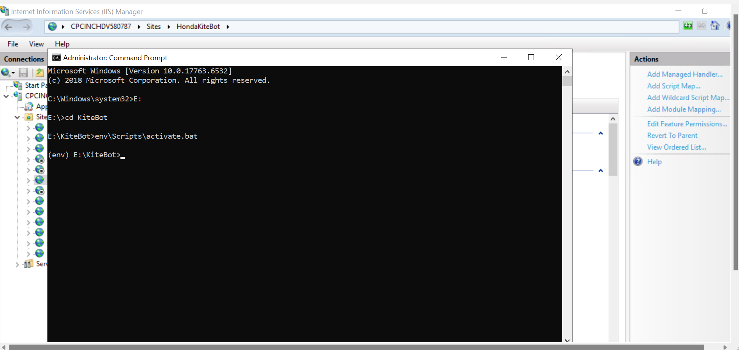

* To install wfastcgi type the below command.

pip install wfastcgi

* After installing, type the below command to enable wfastcgi.

wfastcgi-enable.

* It will give an executable path like the below one.

E:\KiteBot\env\Scripts\python.exe|E:\KiteBot\env\Lib\site-packages\wfastcgi.py

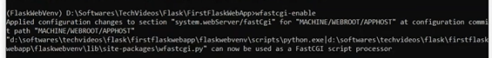

* Now give copy the path and paste it in Handler Mappings executable path (Step 8).

**Step 11:**

* After entering the details in Handler Mappings tab. Click **Request Restrictions**.



* Uncheck the checkbox.

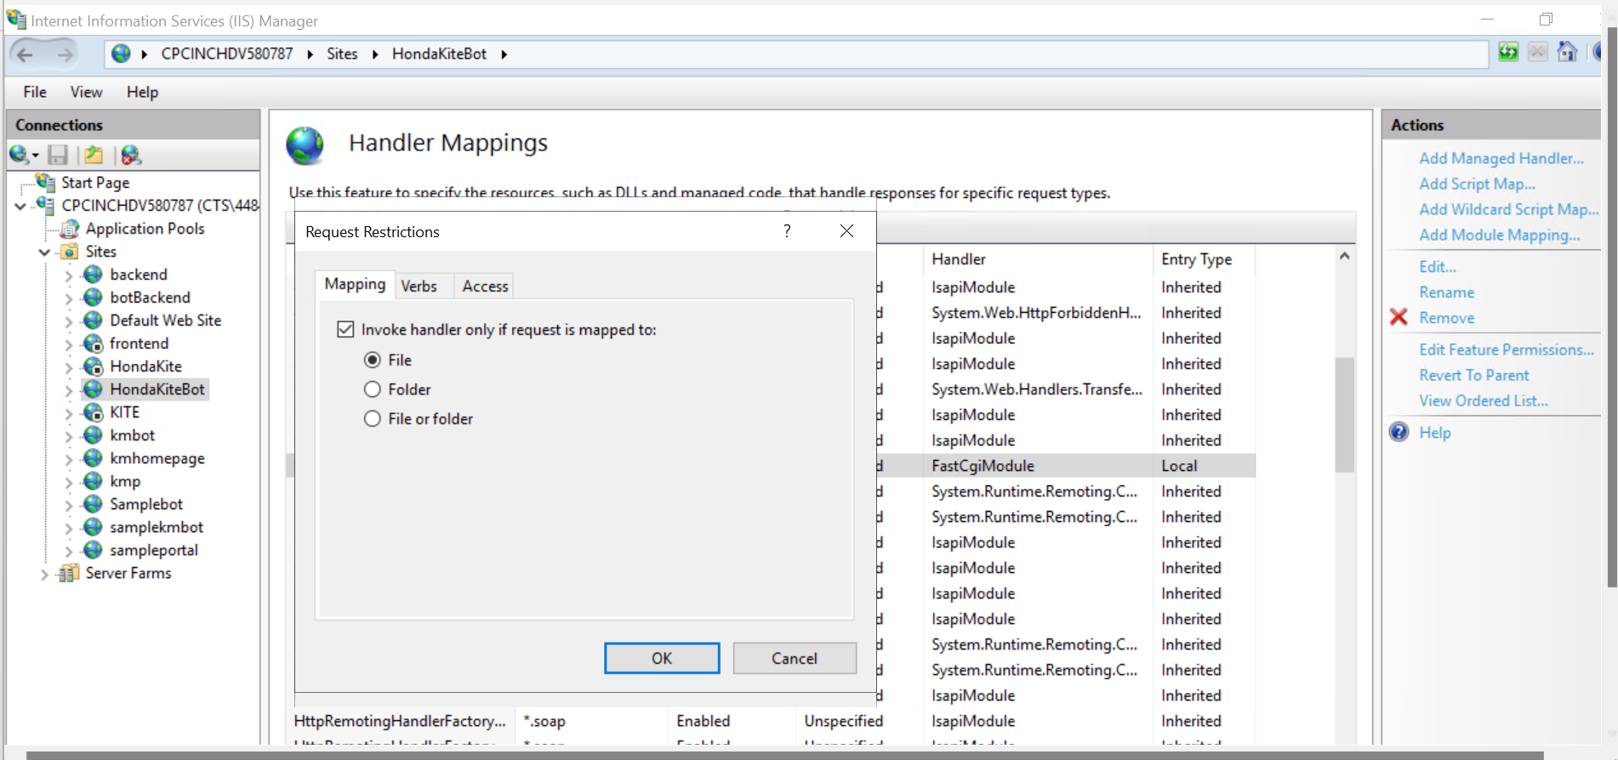

* Click on OK.

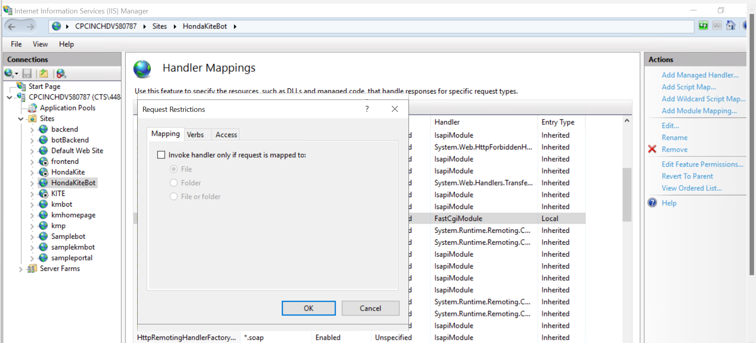

* Again, click on Ok. And then Click Yes.

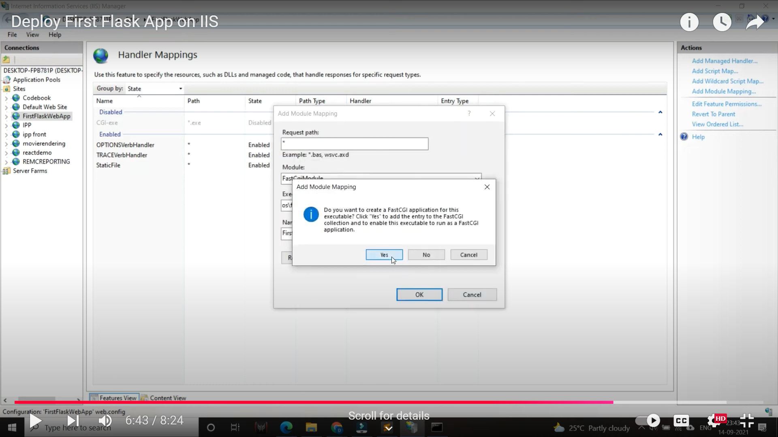

* New Handler Mappings will be added.

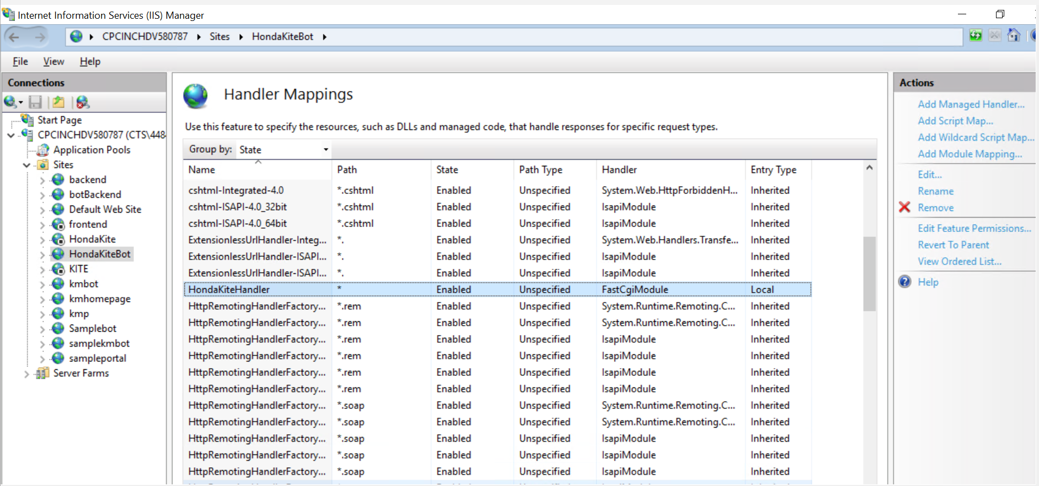

* Click Server Name and then click Fast CGI Settings.

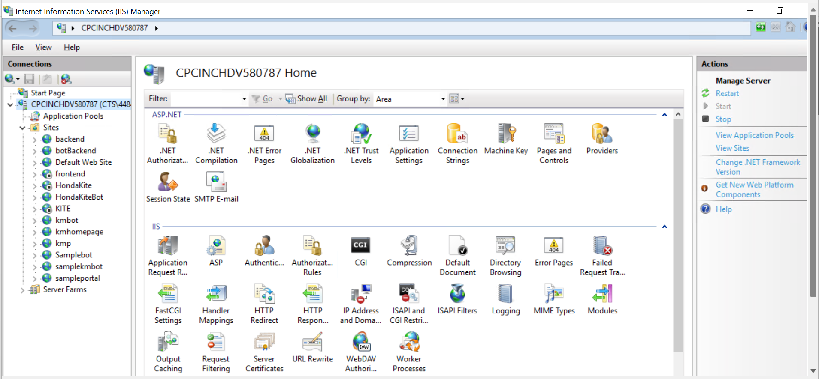

* Double click on the handler which you created.

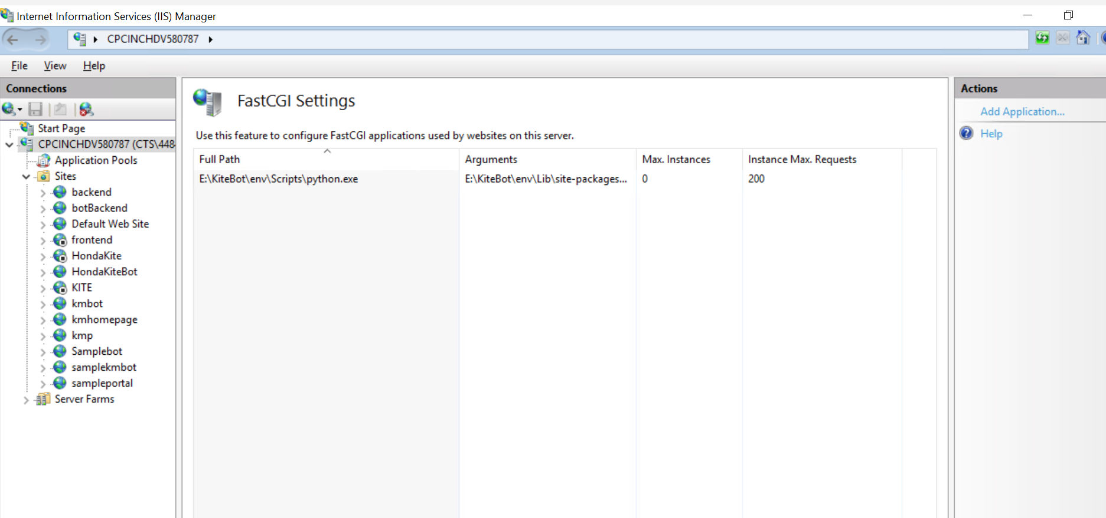

* Edit FastCGI Application tab will open. Click on Collections, then click on the three dots(…)

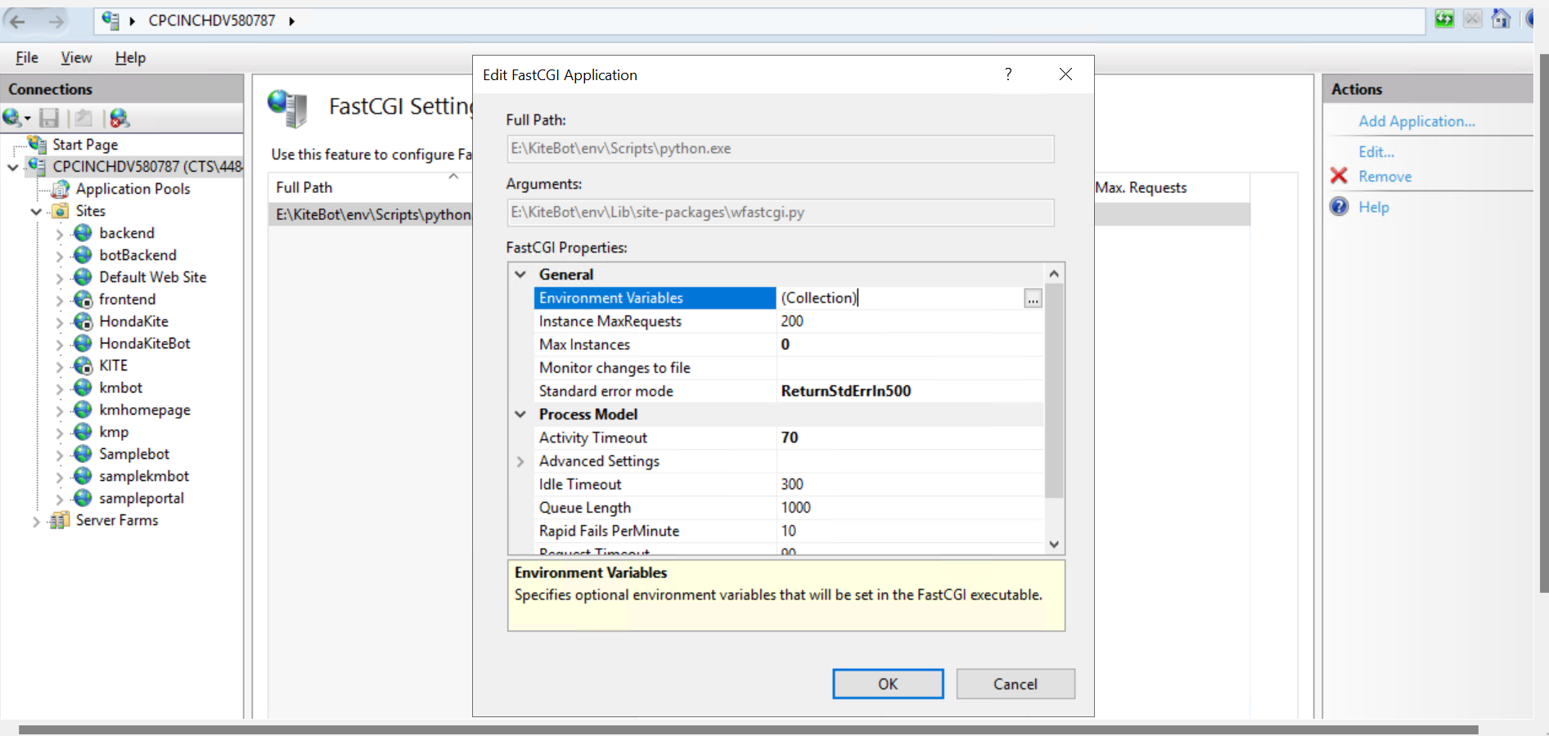

* Click on Add.

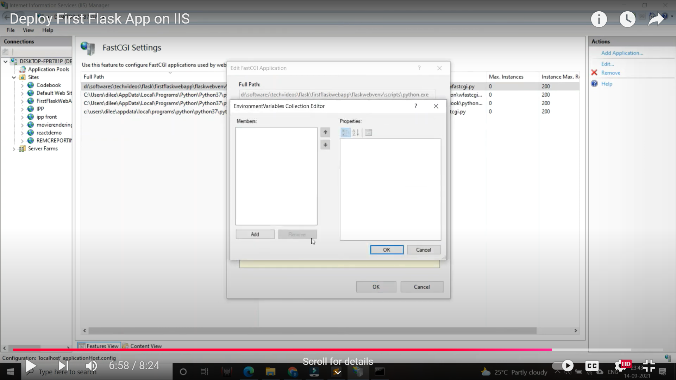

* Enter **PYTHONPATH** in Name field and give your project folder in Value field.

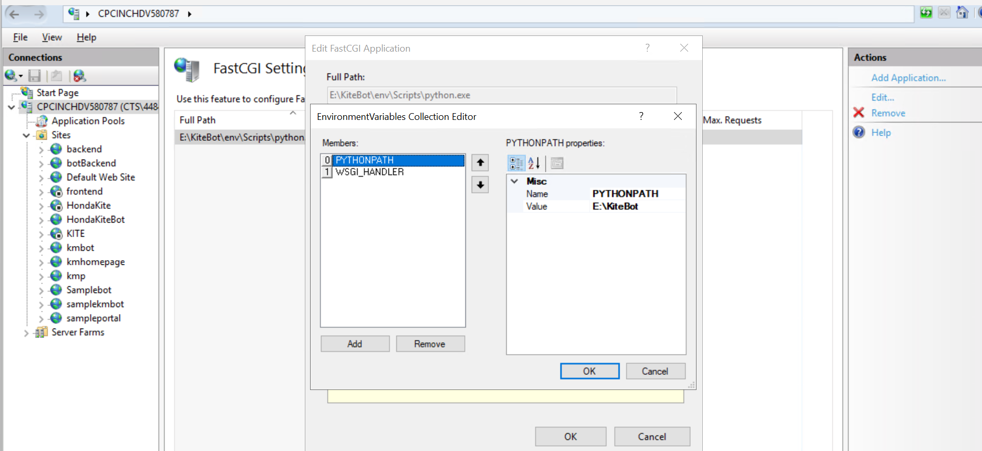

* Again, click on Add. Enter **WSGI_HANDLER** in Name field and enter **app.app** in Value field.

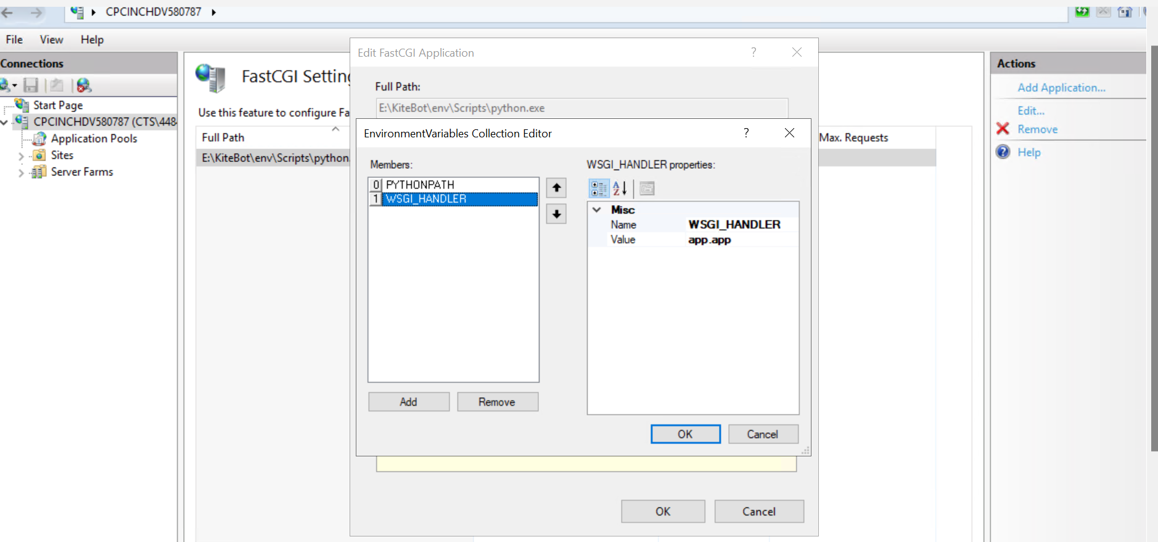

* Click on Ok and then Click on Ok.

**Step 12: Grant Permissions to IIS_IUSRS for project**

* Go to your project directory and right click on your project folder and select properties.

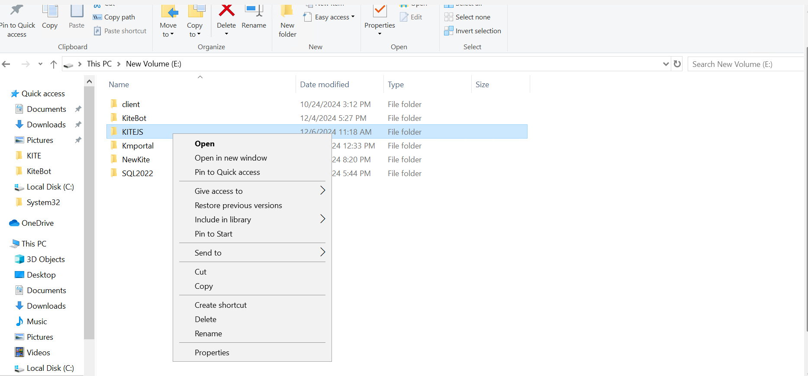

* Click on Security.

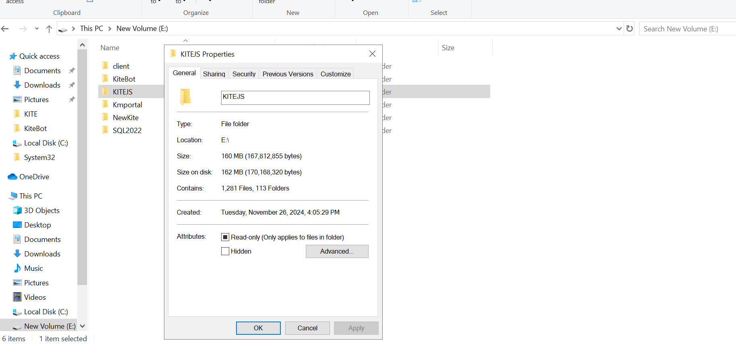

* Click on Edit.

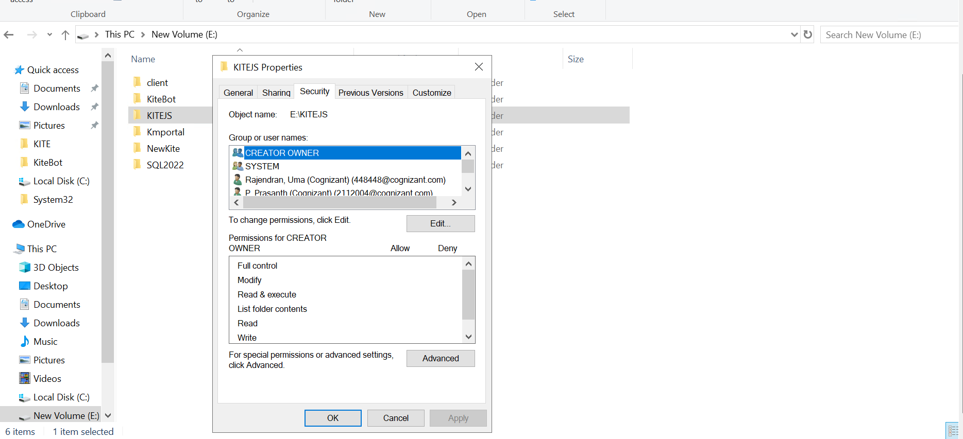

* Click on Add.

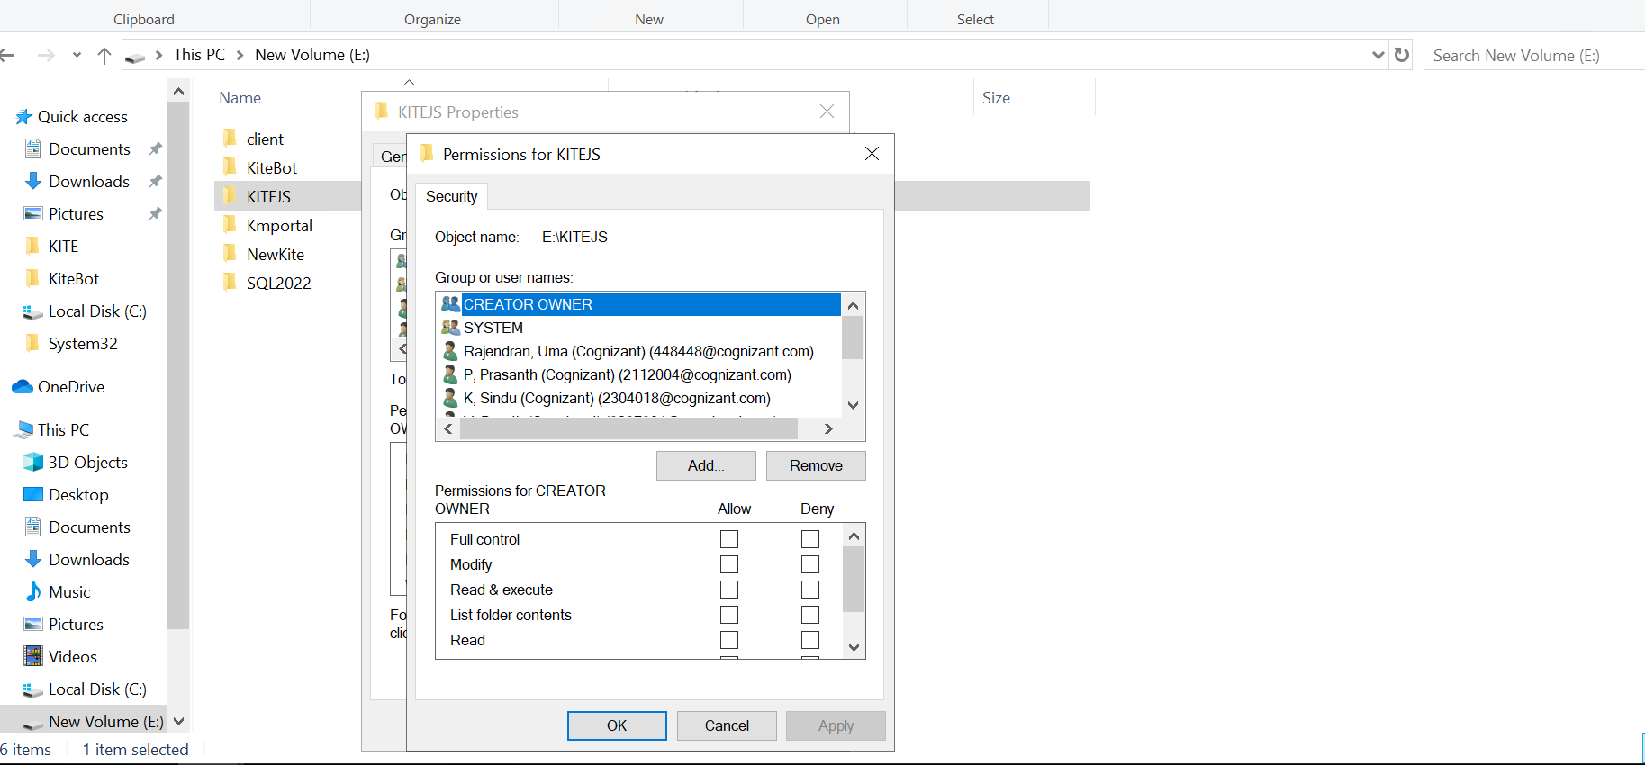

* Enter IUSR and click Check Names.

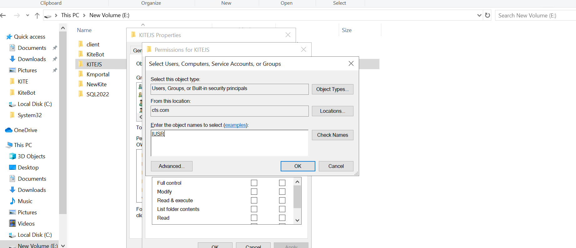

* Enter IIS_IUSRS and click Check Names. Click on Ok.

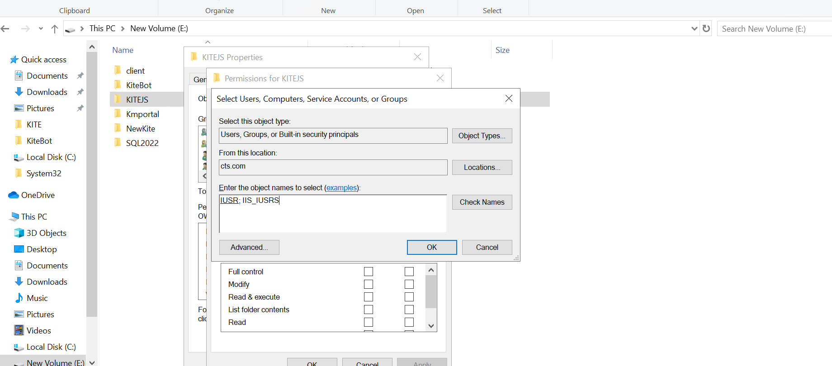

* Click on Object Types.

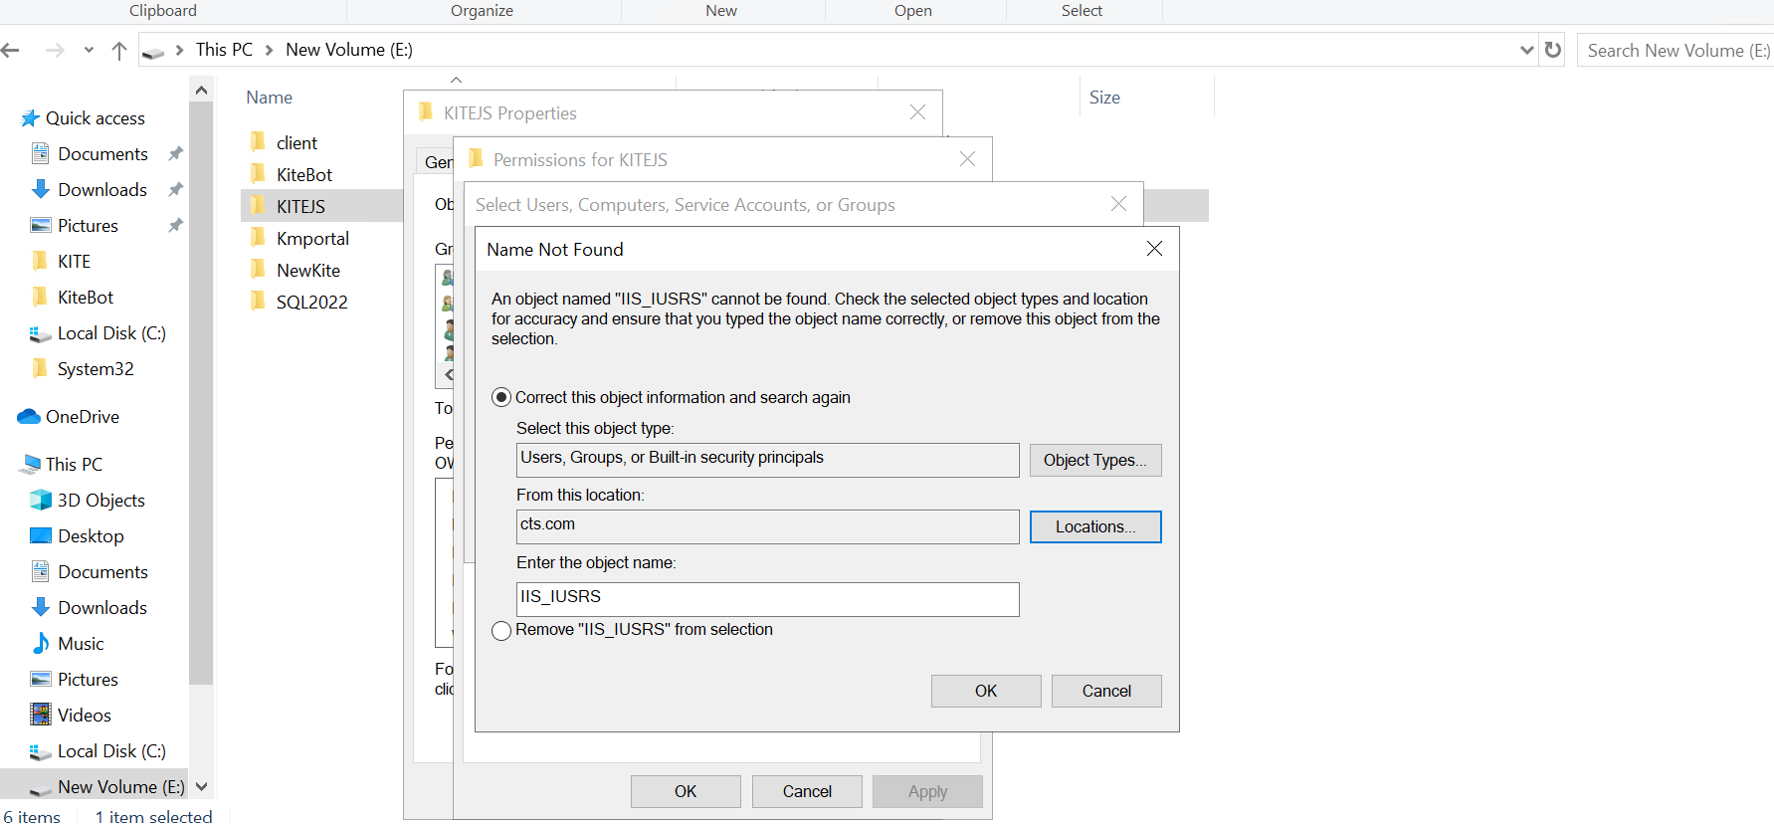

* Select Users, Groups, Built-in security principals. Click on OK.

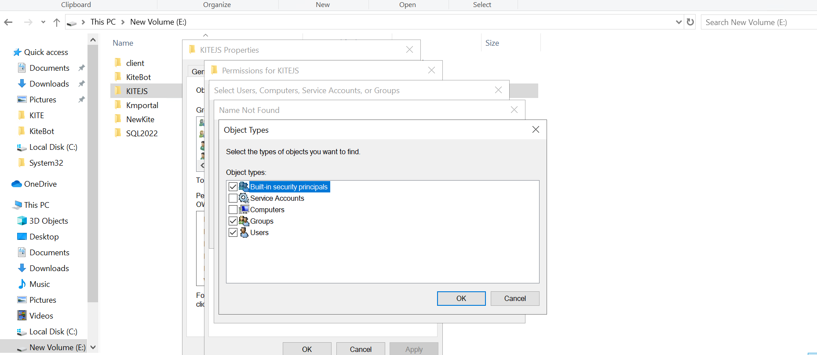

* Click on Locations.

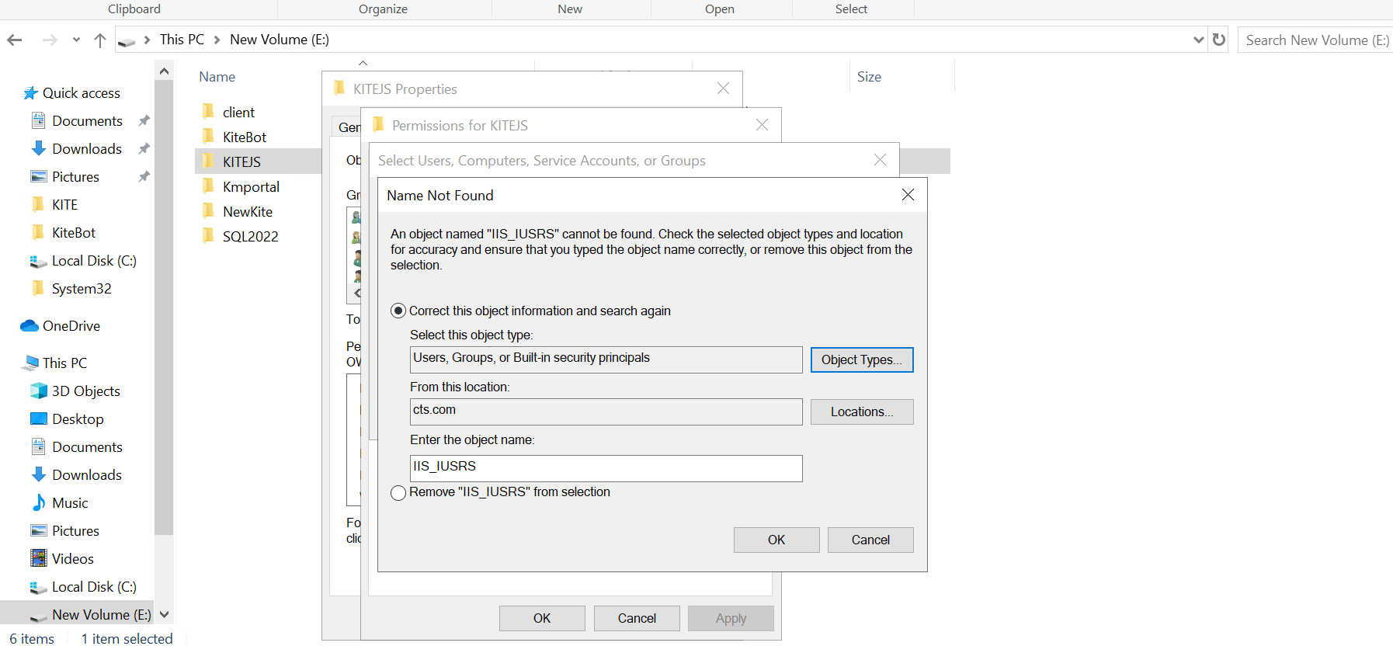

* Select Your Server Name. Click on OK.

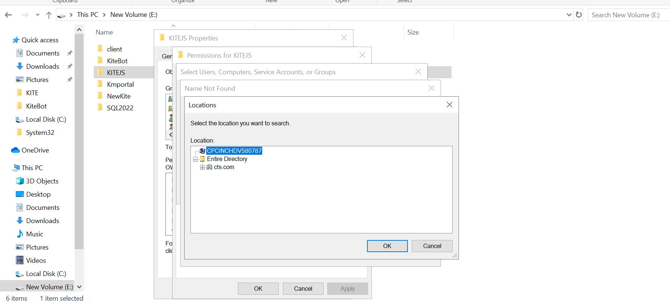

* Click on OK.

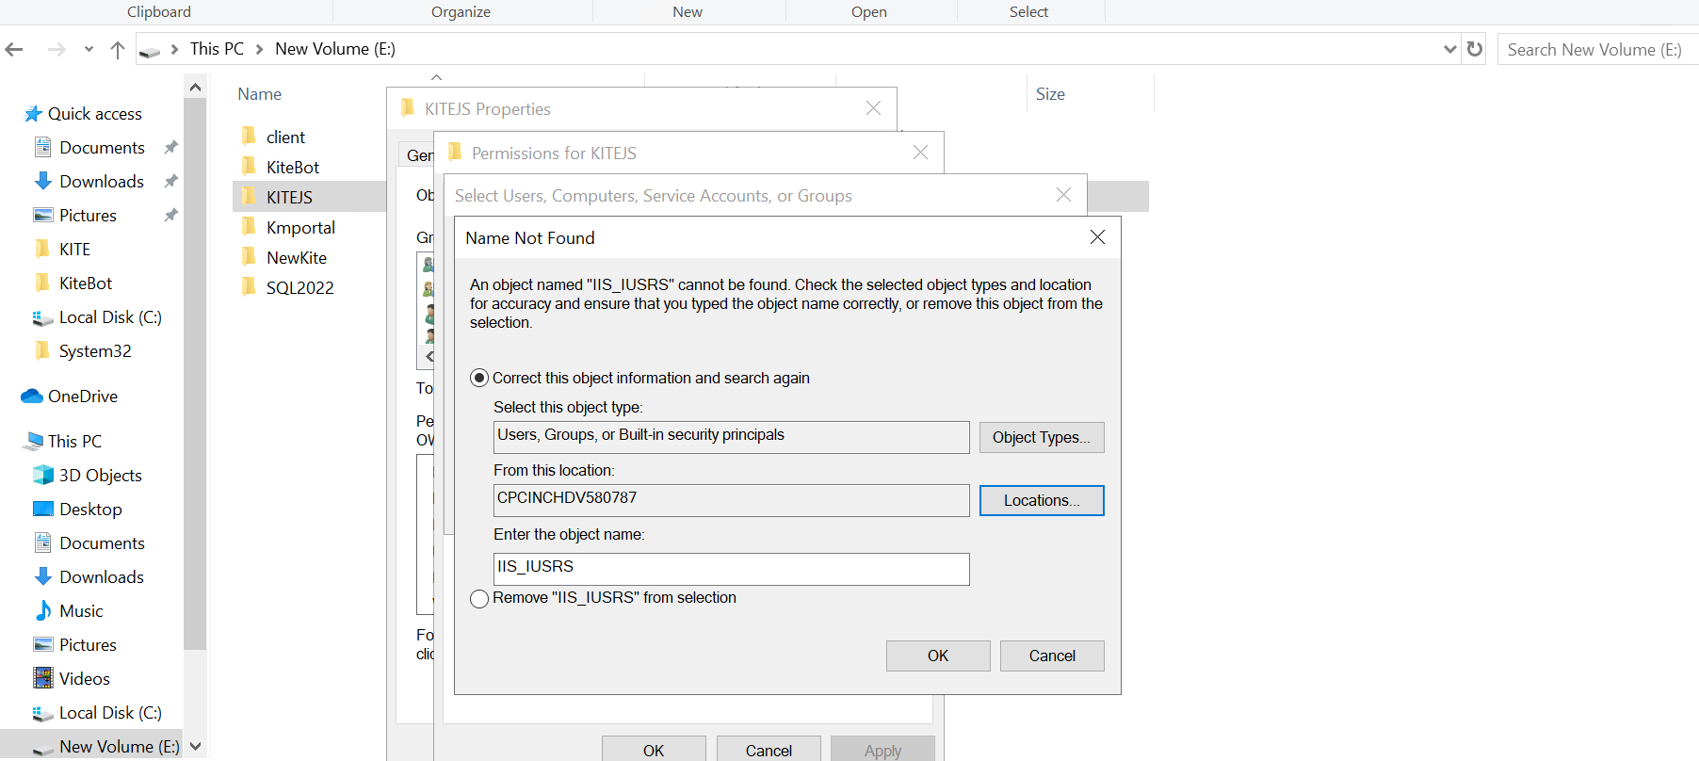

* Click on OK.

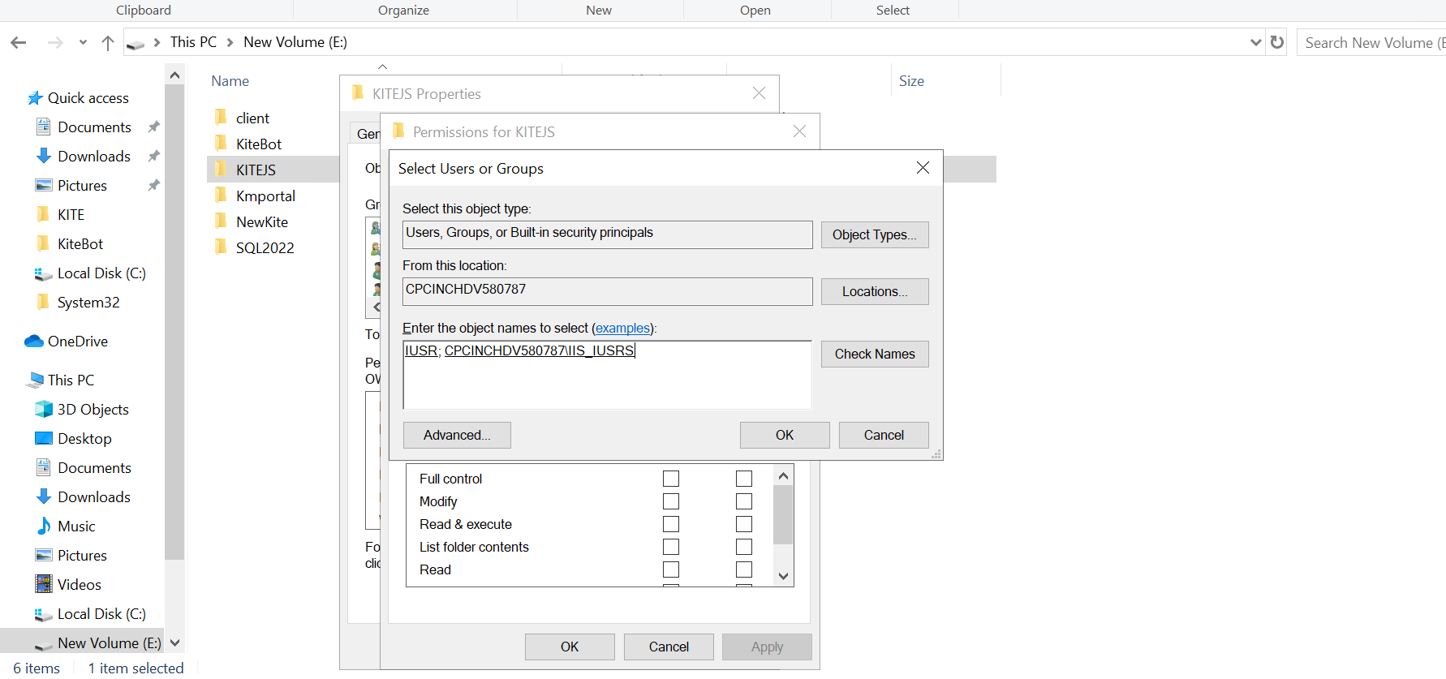

* Select IIS_IUSRS and Click the Full control Allow check box. Click on Apply and then click ok.

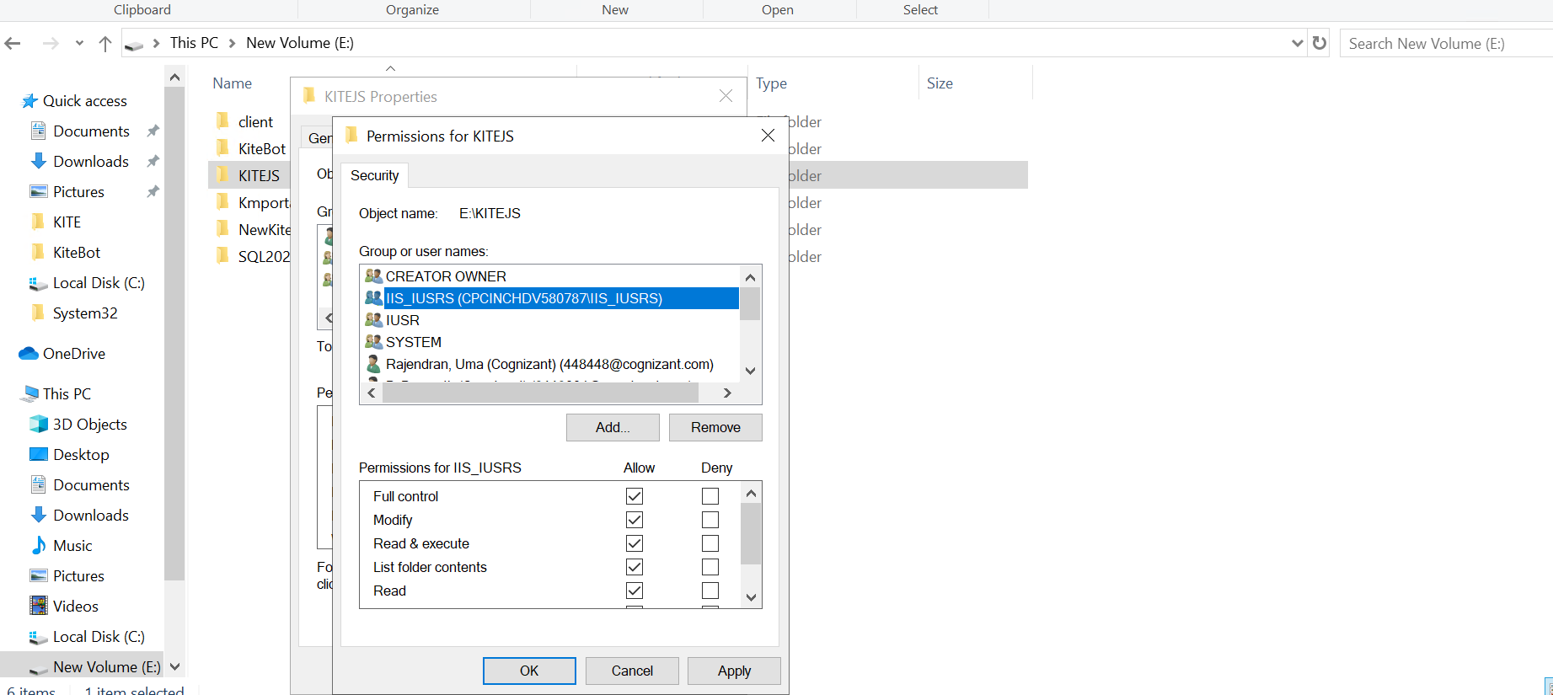

* Click on Ok.



**Step 13: Grant Permissions to IIS_IUSRS for python**

* Click on Search and type Python. Click on open file location.

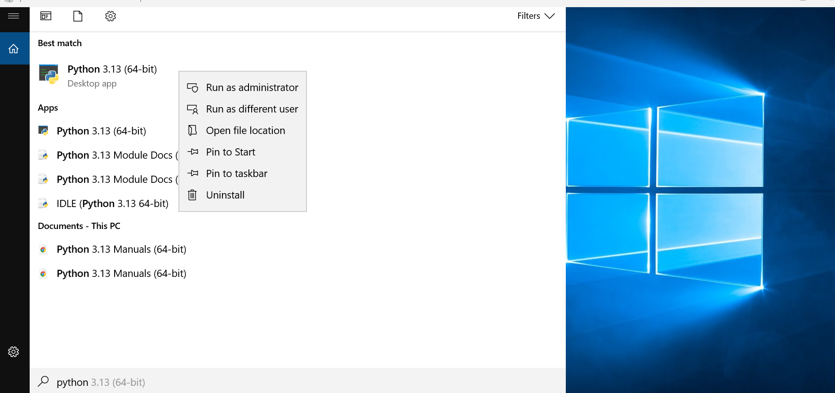

* Right click on python. Click on open file location.

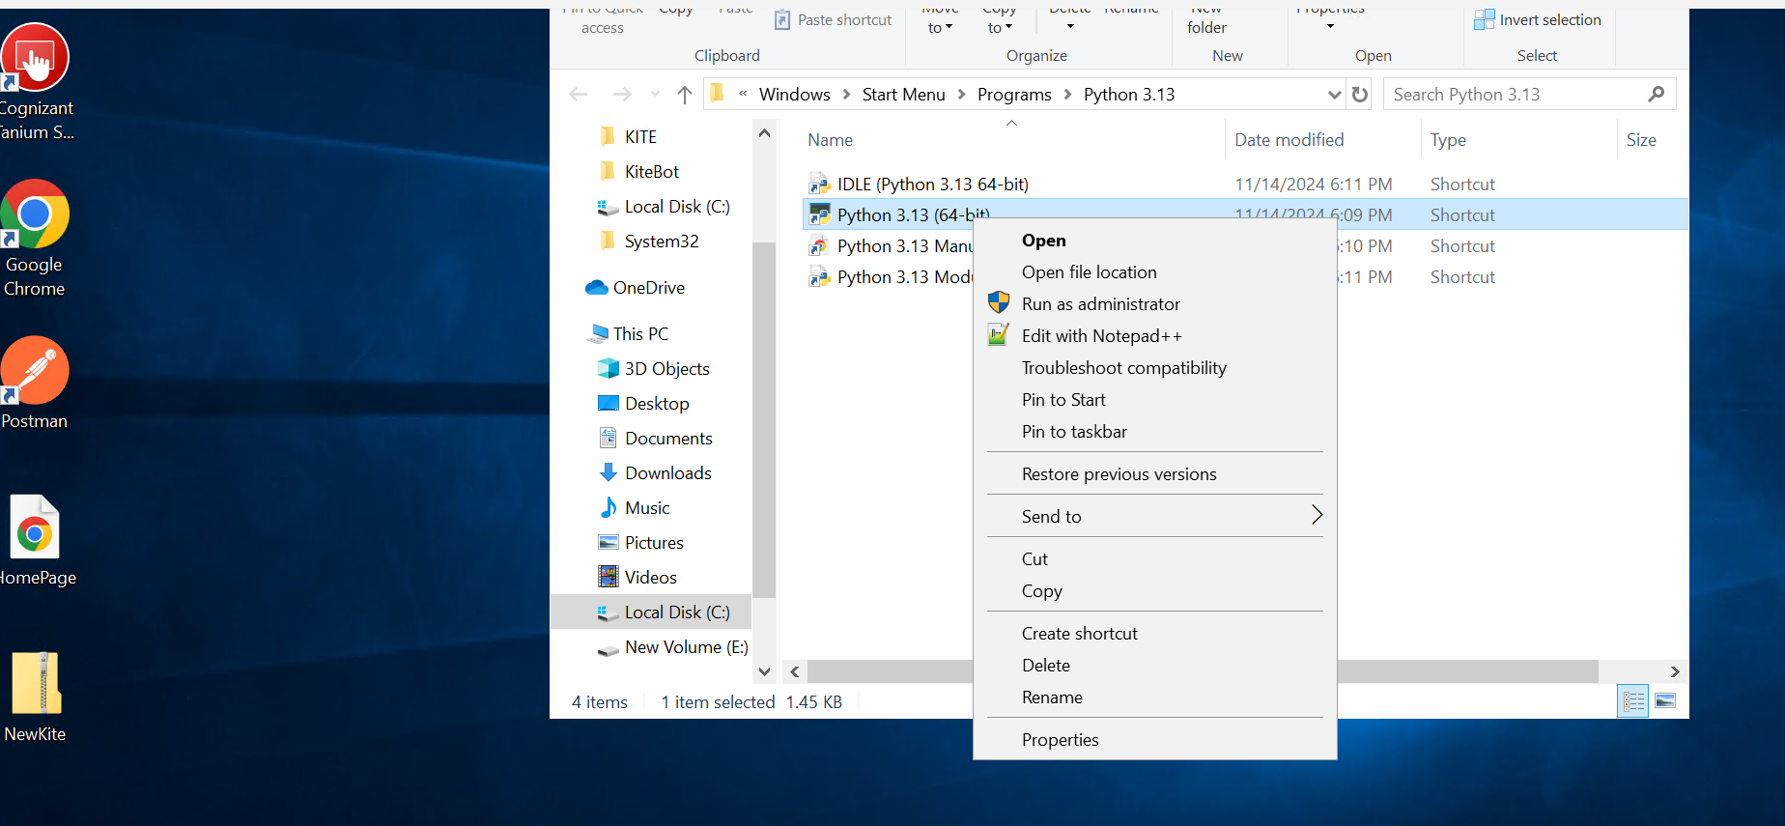

* Go back to Python313 folder.

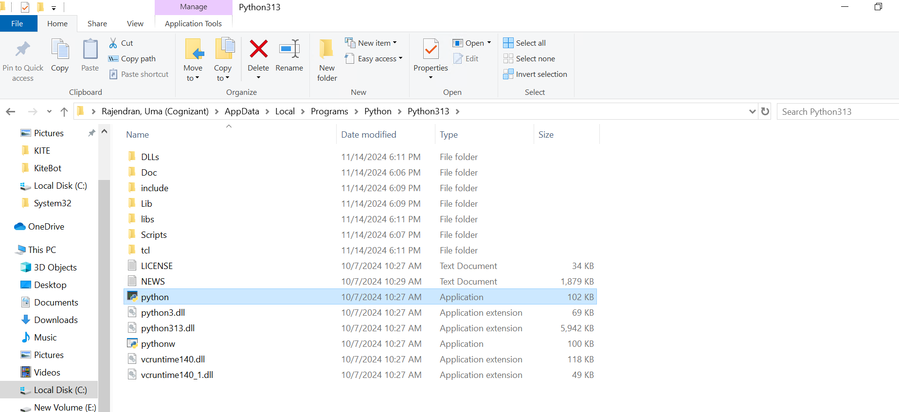

* Right click on your Python313 folder and select properties.

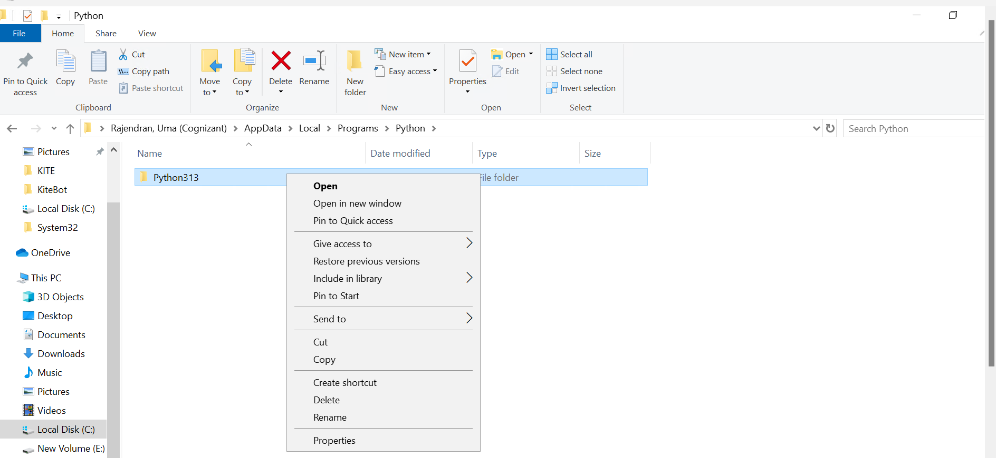

* Follow the same steps which is mentioned in step 12 to grant permission.

**Step 15: After Giving permissions, open Note pad as an Administrator.**

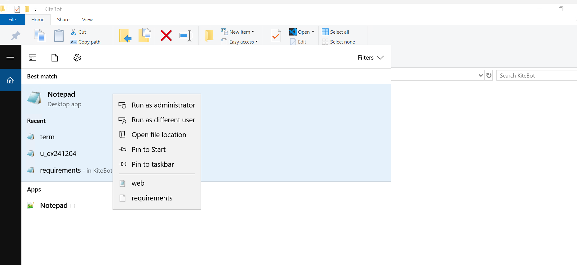

**Step 16: After Giving permissions, open Note pad as an Administrator.**

**Click File >Open**

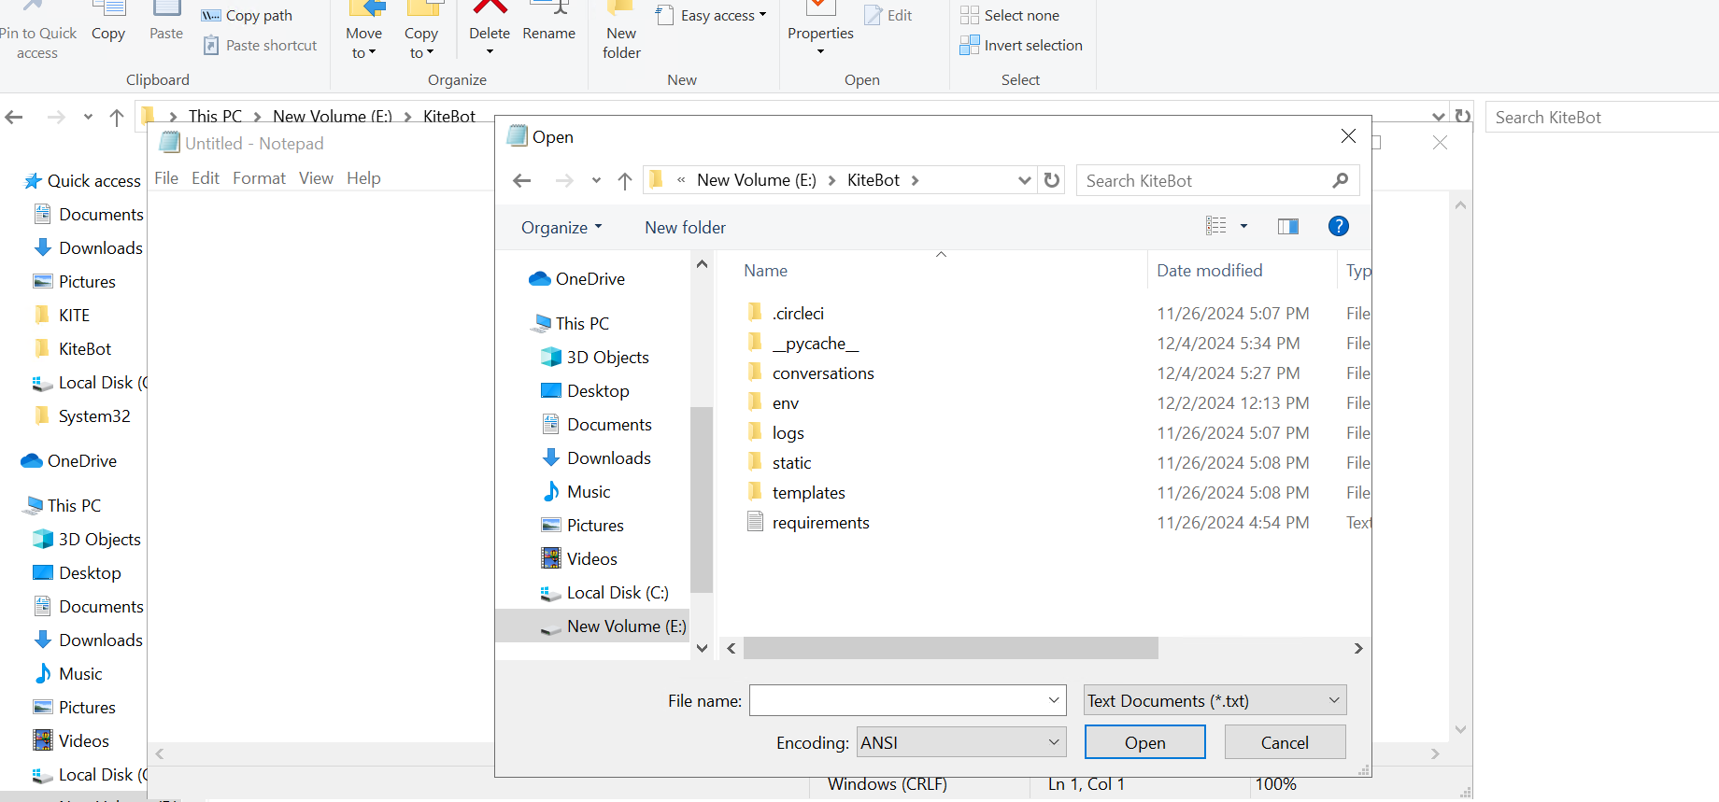

**Step 17: Select All files from dropdown.**

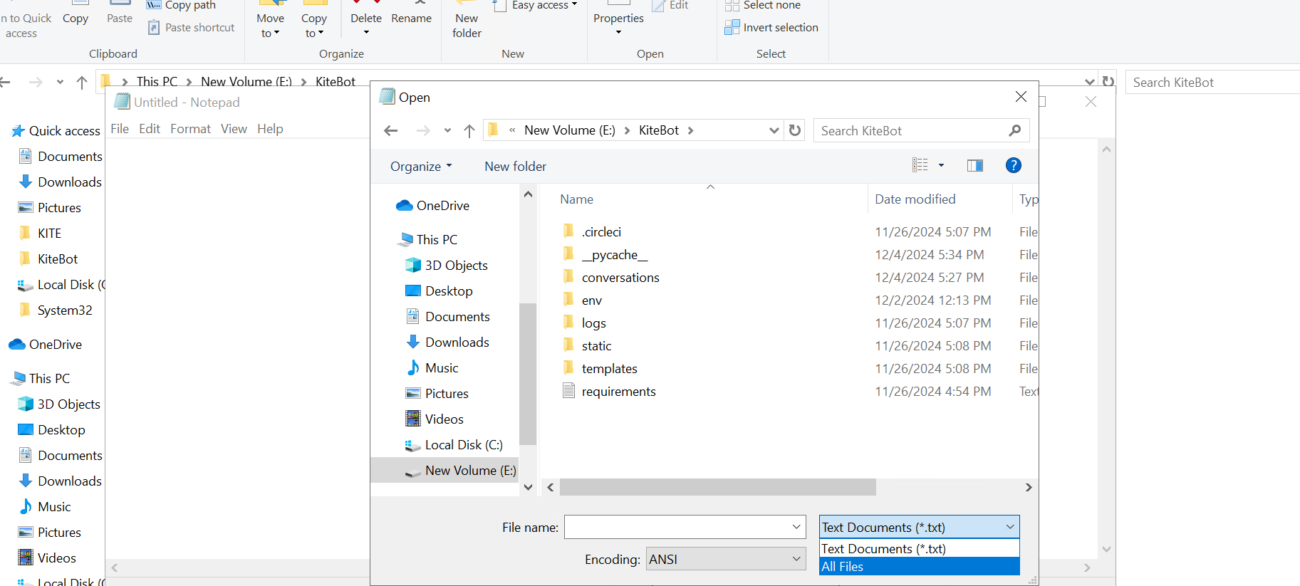

**Step 18: Open the web.config file.**

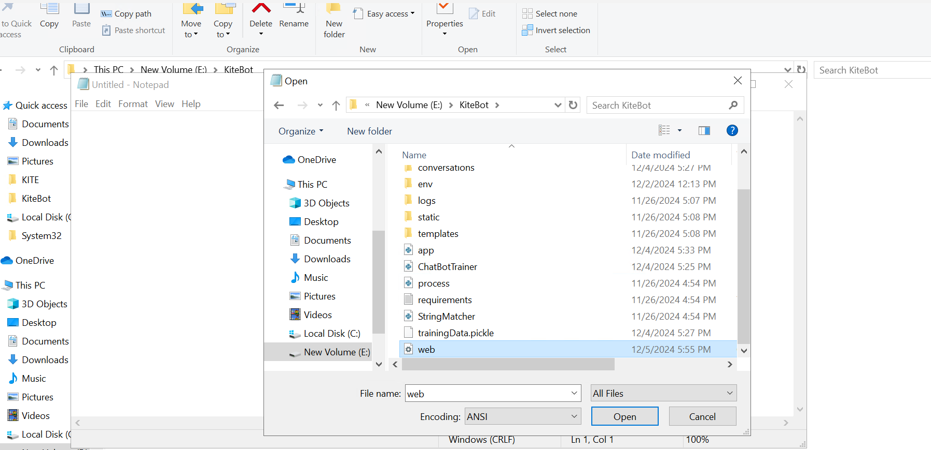

**Step 19: Configure the web.config File**

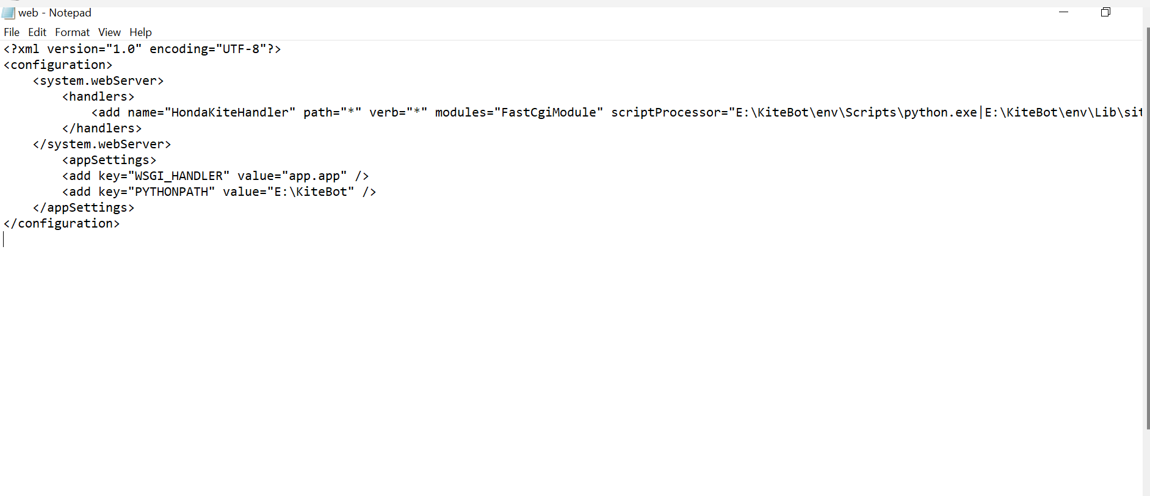

**Replace the following:**

* scriptProcessorwith the path you noted earlier.
* PYTHONPATH with the path to your project directory.
* Save the file and close it.

**Step 20: Go to IIS. Click on your Site. Click the Stop button under Manage Website.**

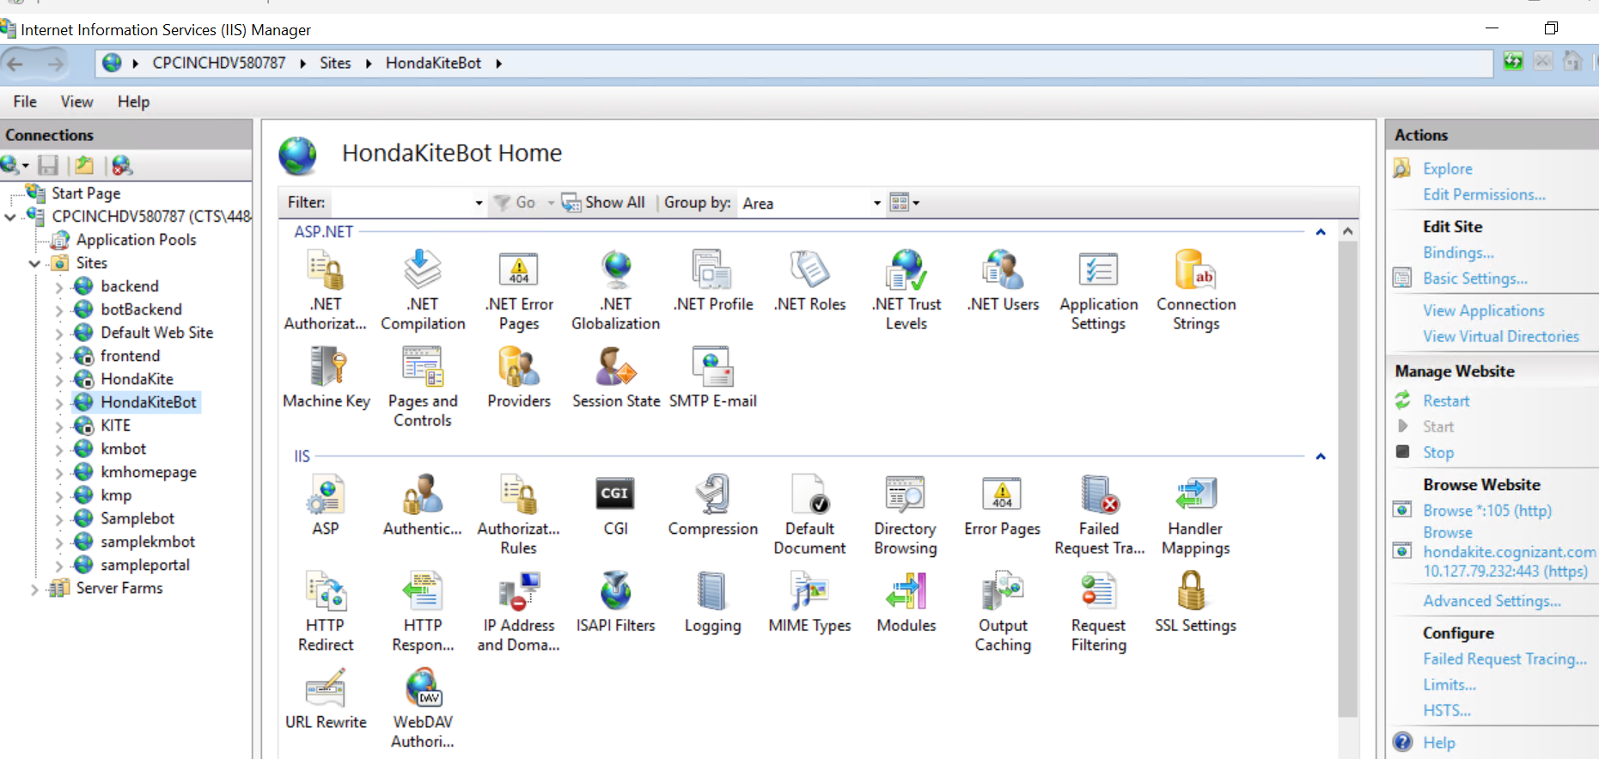

**Step 21: Click on Start then click Browse under Browse Website.**

